Session-5

**Schema:**

* Schema is a mandatory Database Object.
* SYS,_SYS_BIC,_SYS_BI… is the SAP delivered schema.
* All the schema stored under catalog section.

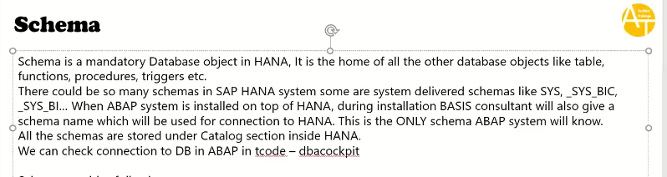

**Tcode: DBACOCKPIT**

* Know the which database has connected our SAP system.

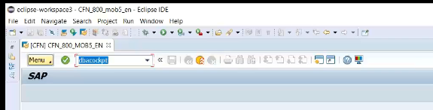

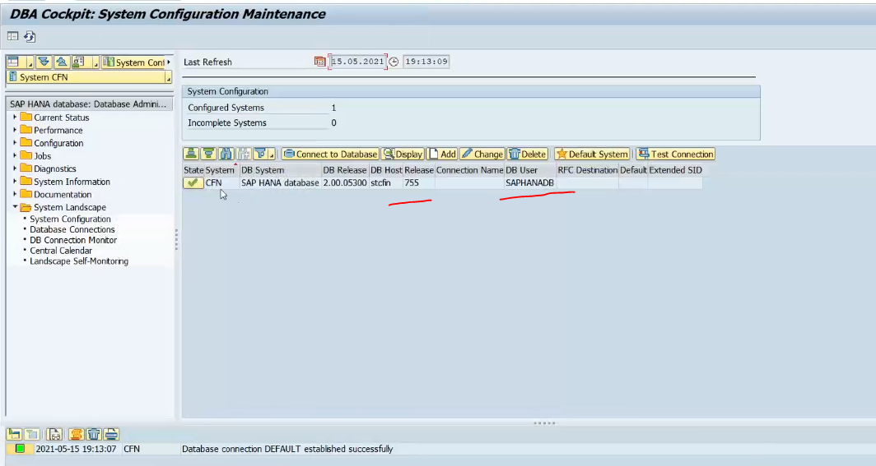

What is the schema database connected too?

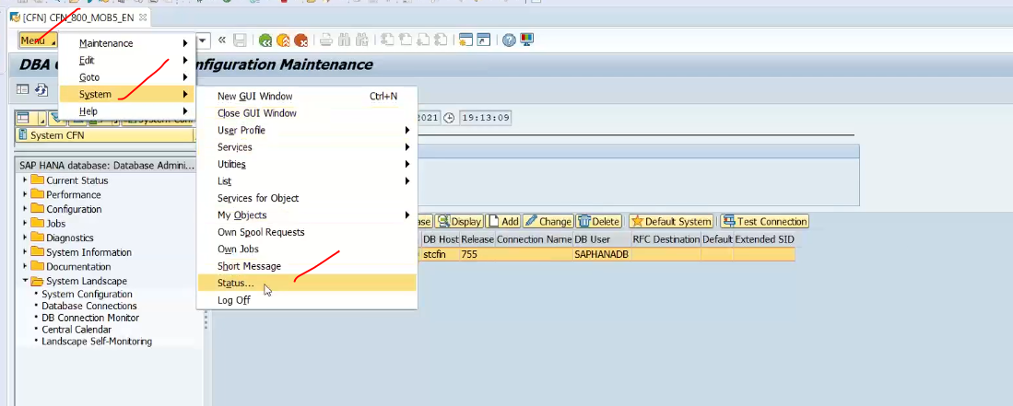

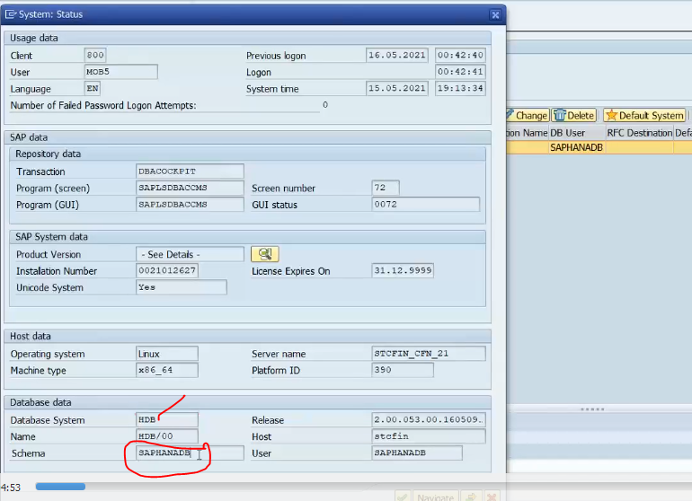

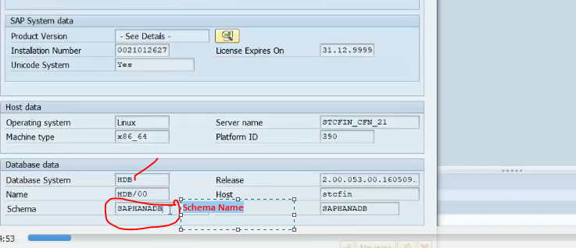

Hana Database connected to schema called “SAPHANADB”

If I go to HANA Database I will definite fine the schema: SAPHANADB in my hana DataBase.

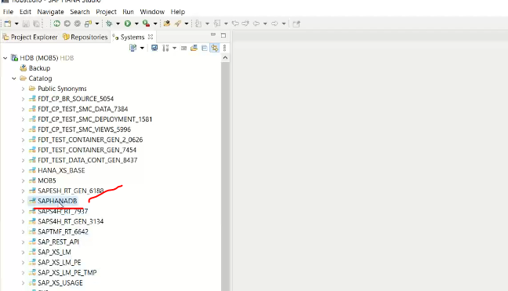

If you connect your company HANA system, you don’t find the schema related to ABAP, does it mean that no schema created for ABAP system. 🡪 this is impossible to that ABAP system connect to HANA does not have a schema. 🡪 it is mandatory otherwise ABAP system is invalid.

If you may not find the schema (ABAP schema)means because of authorization/security or some people might hide this.

Shema Uses:

* Providing security at object level, who can insert, select, delete, update data inside the system.

If you go to security folder, and open any user, you will see 🡪 you can give schema privelages.

* + Under object privileges you can add the schema.
  + ADD the “SAPHANADB” schema. 🡪decide what this person can do /can’t do inside the schema.

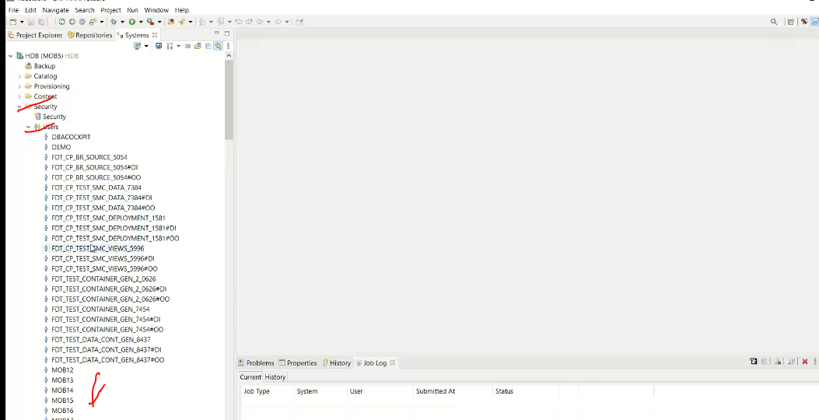

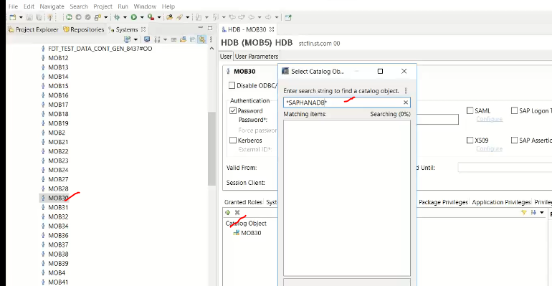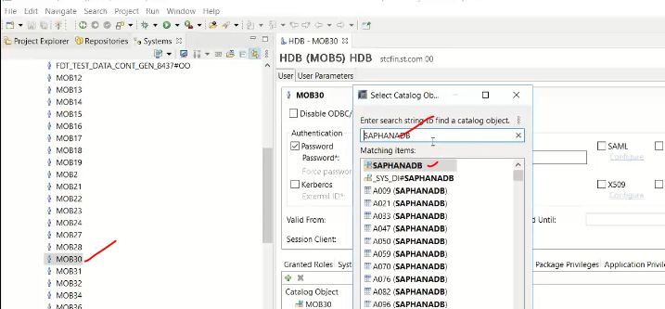

Next screen will show added the SCHEMA to the user, and here only you can give the priveleges to the user, to give access to the schema from the user.

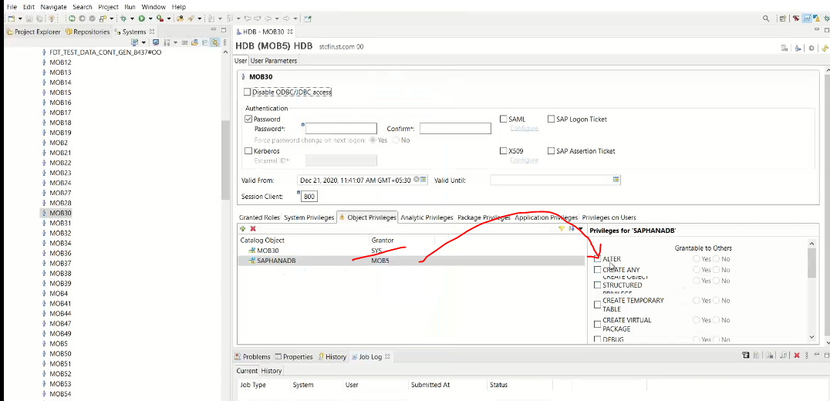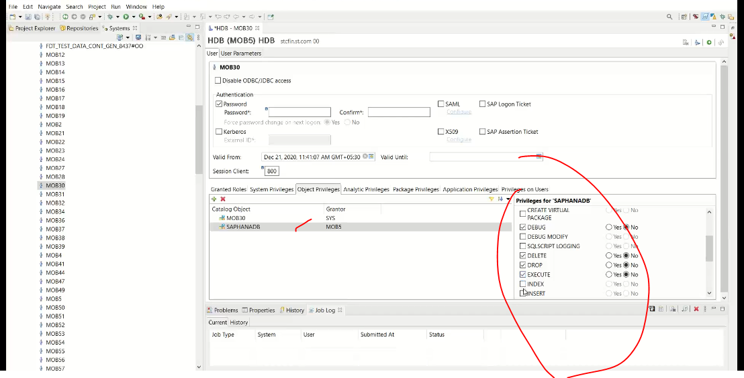Note : schema provides securities.

* When a user is created a schema with same name as user name will be created in the system.

If you go to hana, I am using user – MOB5, which means 🡪 when I see catalog I will also see a schema with name od user-(MOB5)

MOB5 is the user name and schema name.

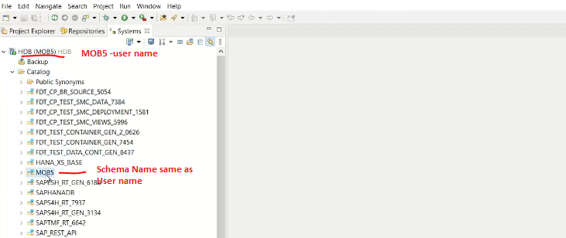when a user created schema name as user name created.

Note: what is the significance of this user name-schema.? Why system created the same name as user name.

Ans: it is the same significance like local object.

* + In ABAP system $tmp as local package, use is all the testing objects or all the learning/training testing everything which developer do they don’t want to ship to the customer.
  + USER name schema is equals to the $tmp in abap system.

Note: all the schemas not appearing of the different users? Why I am unable to see other users schemas. 🡪 means exactly as security. We are unable to see other users

Note: ABAP will only talks to ABAP relevant schema in our case-SAPHANADB

* All our SAP tables available under the schema- SAPHANADB i.e ABAP schema.

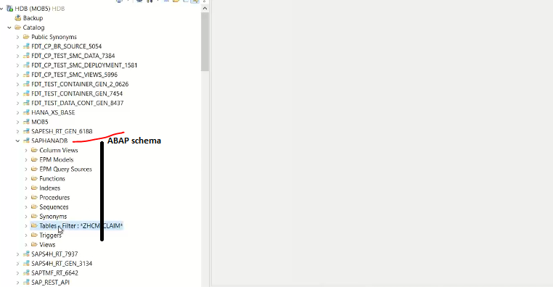searching –MARA table in side the ABAP schema under the table category.

Filtering “MARA” in ABAP schema.

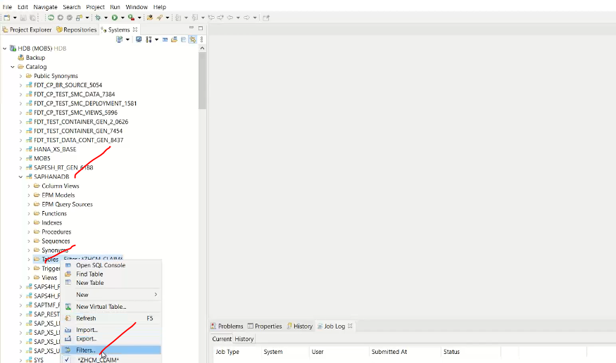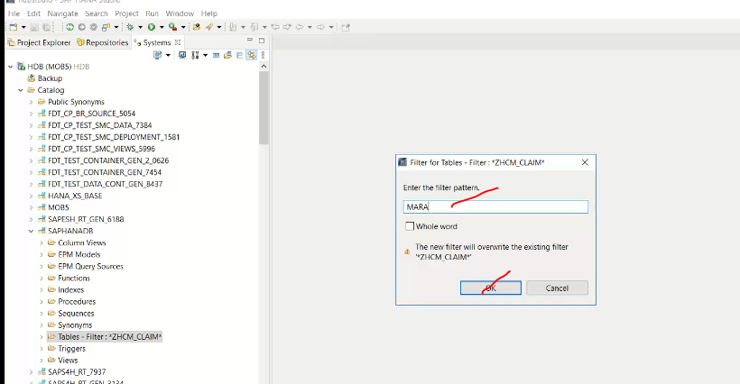

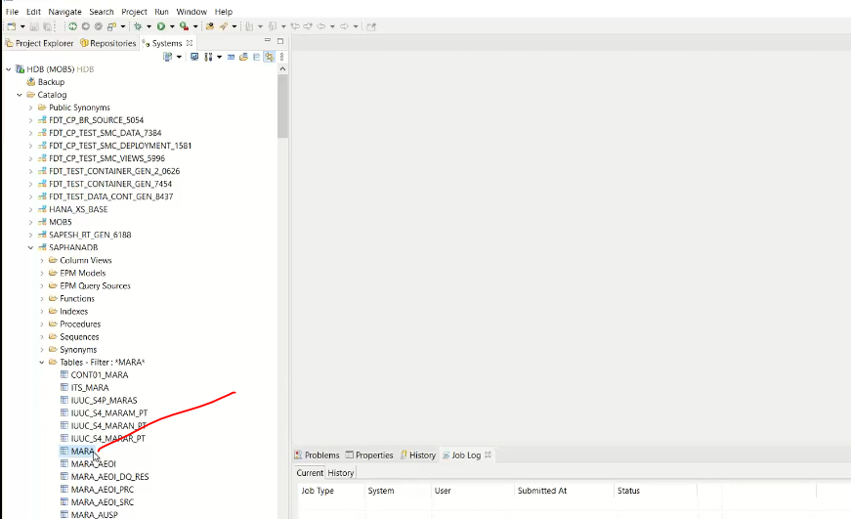

To see the field names in MARA

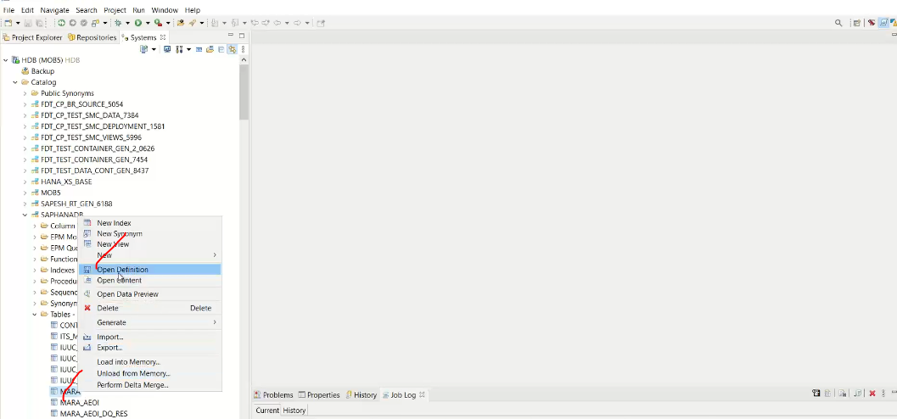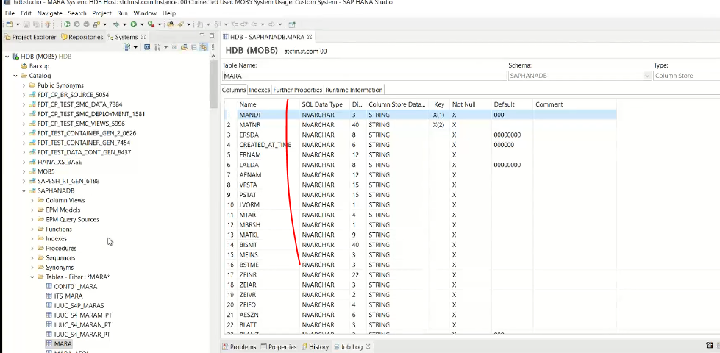

Note in HANA DB to talk to abap system use it “SAPHANADB”, this is the only schema. ABAP Schema name is different for system to system

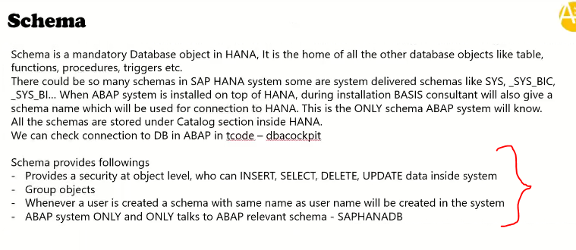

PACKAGES in HANA box.

Why we need the packages? 🡪 Packages are used for design time objects.

* For security purpose. 🡨 suppose our team developing objects, we don’t want to show up to others then we can use it as separate package create .

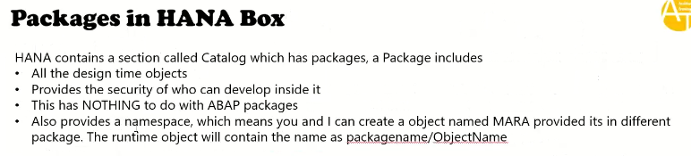

Migration or Conversion: Migrating from a oracle DB to HANA DB is called as Migration Project.

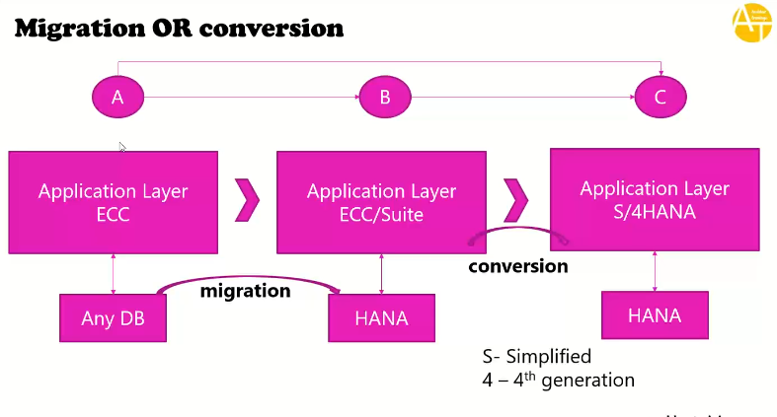

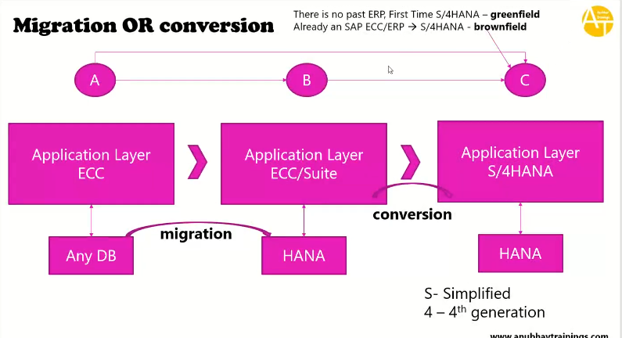

A🡪B 🡪 is database changing

B🡪C 🡪ECC system changing

A🡪C 🡪DB and system changing.

ORACLE 🡪 DB2 -🡪 eventually same stuff and samething.

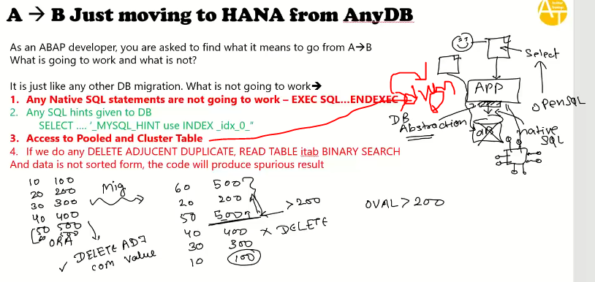

SCI-ATC:

SAP CODE INSPECTOR/ABAP TEST COCKPIT

SCI-Tcode:

VARAINT NAME- FUNCTIONAL_DB

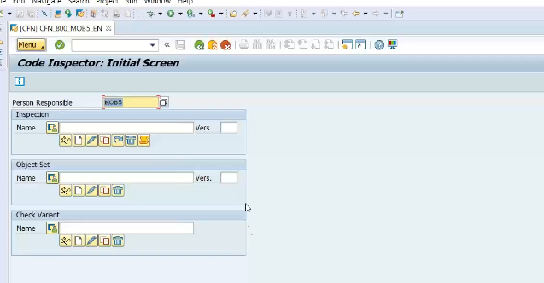

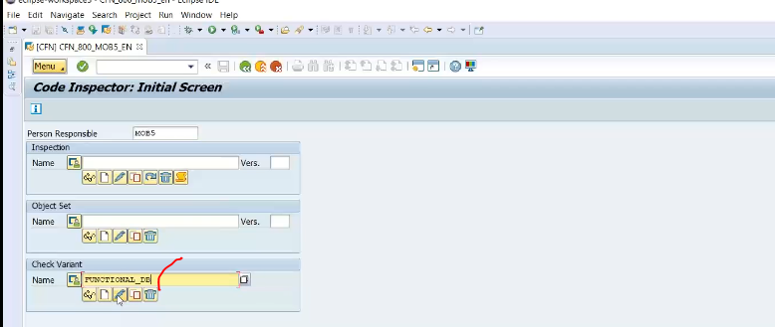

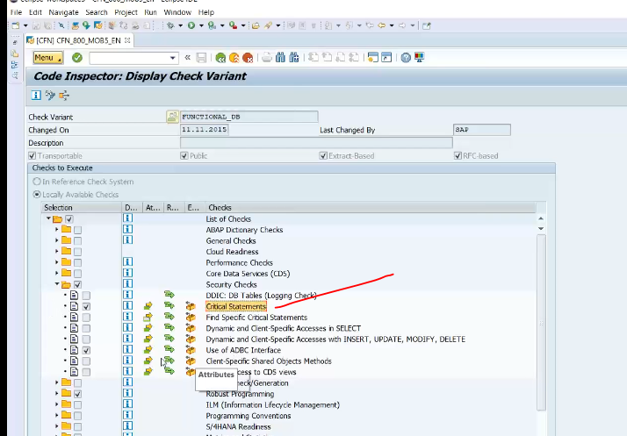

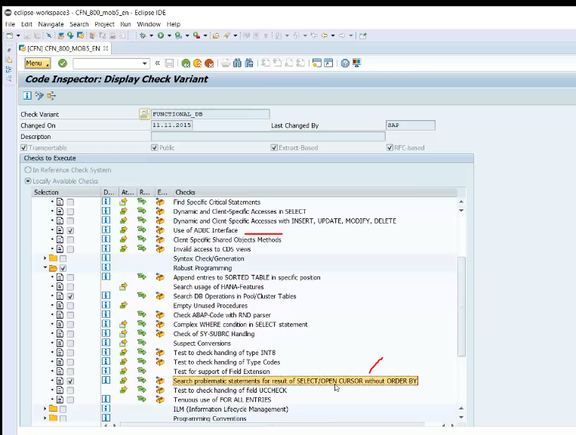

36:00

How to use this variant to your program?

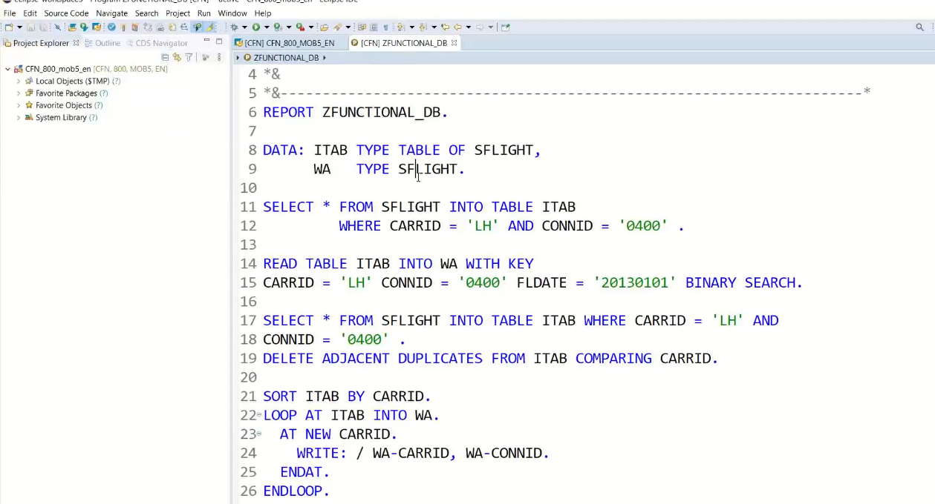

Progrm Name: ZFUNCTIONA_DB.

GO to SCI:

VARIANT: FUNCTIONAL_DB

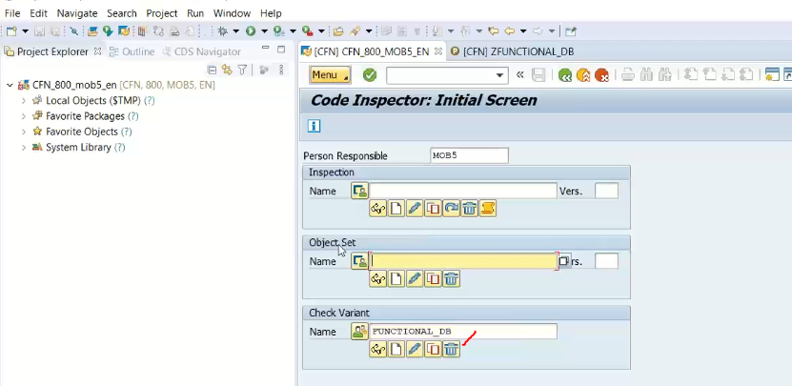

Give your own name for Object set- create object set.

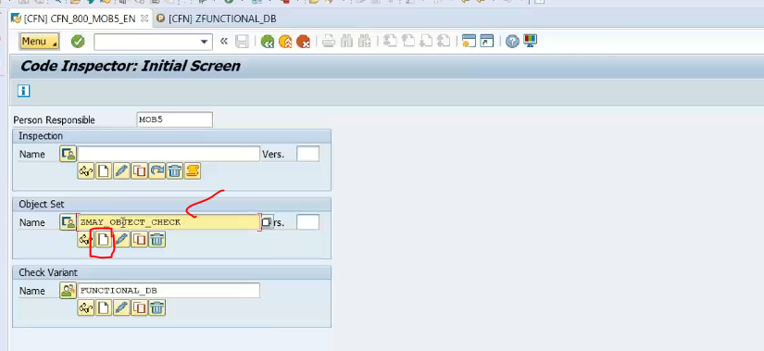

Then choose the program only in below screen.

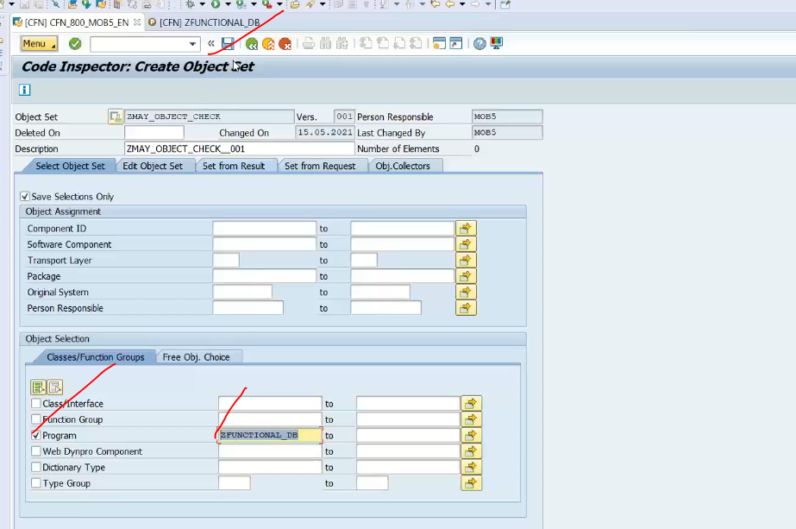

Click on SAVE. 🡪 object set has been saved successful.

Next step: create inspection used for carry out these change.

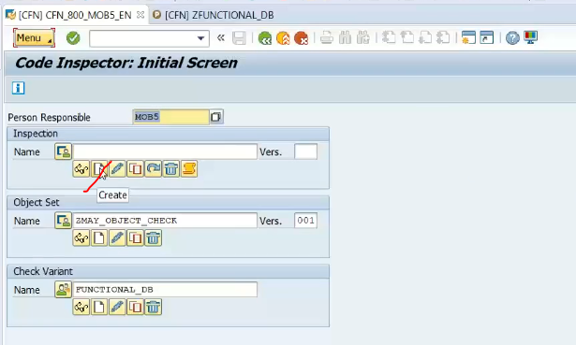

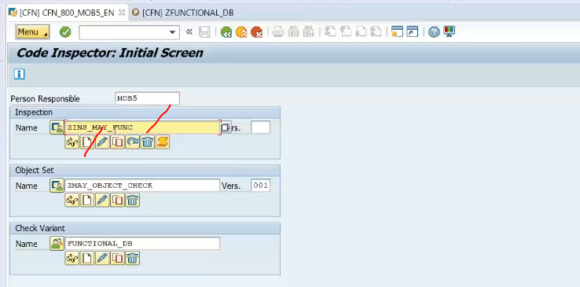

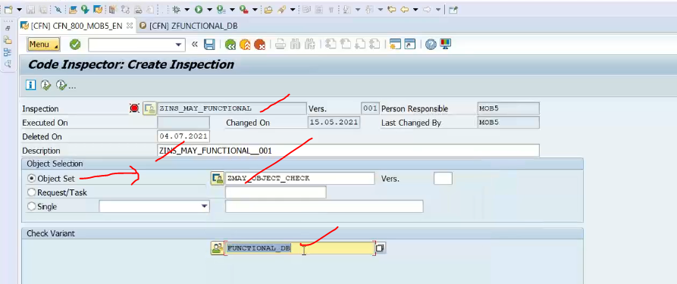

Execute it: and click on results.

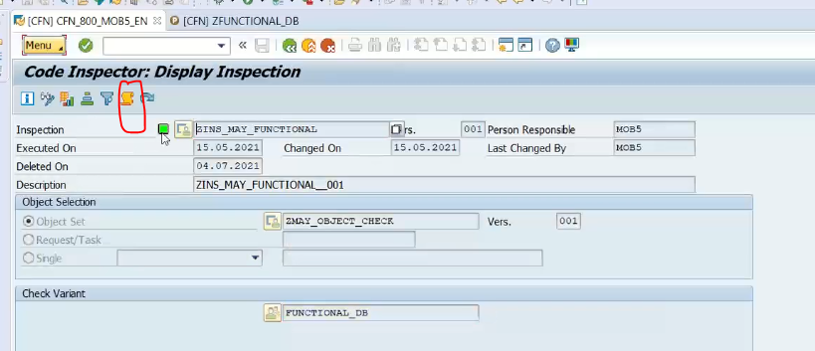

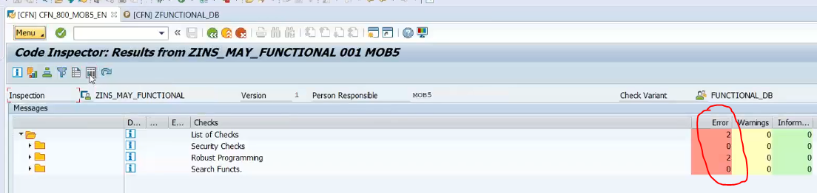

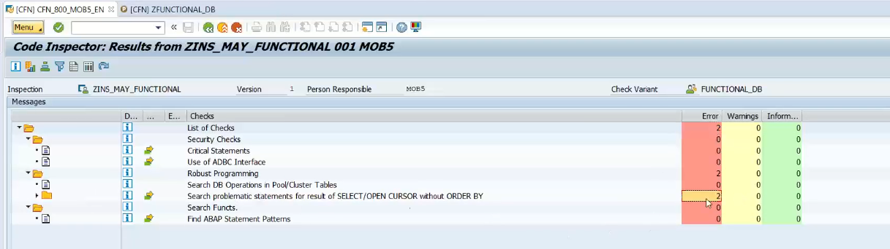

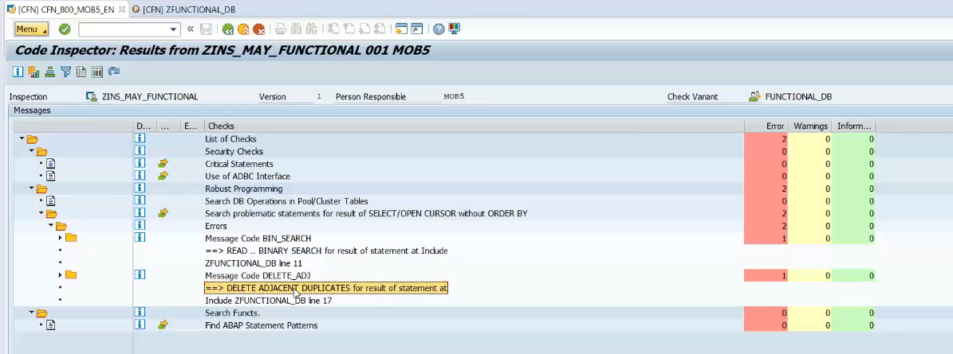

Next tool is ATC checks.

TCODE:ATC.

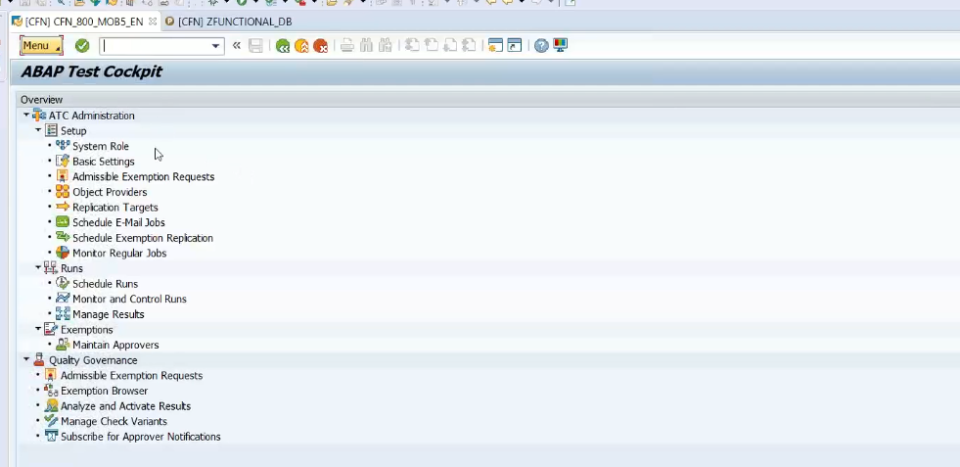

Go to schedule RUNS and execute

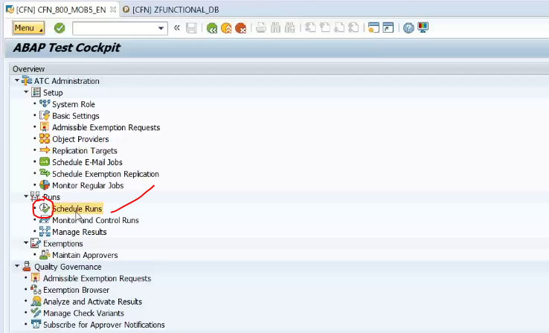

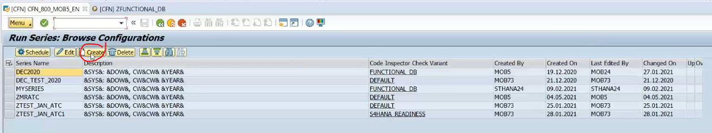

Click on create button in above screen

To create the new schedule.

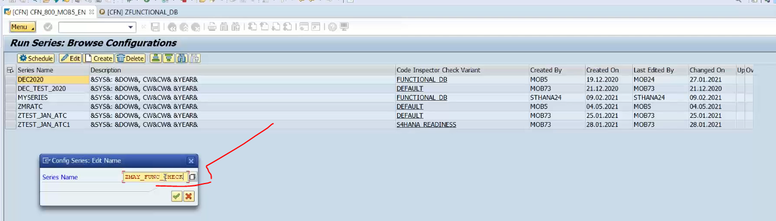

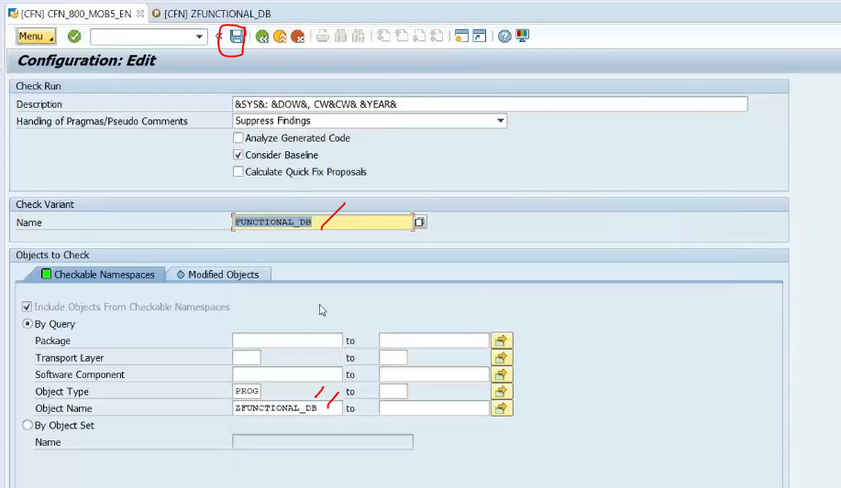

Save it

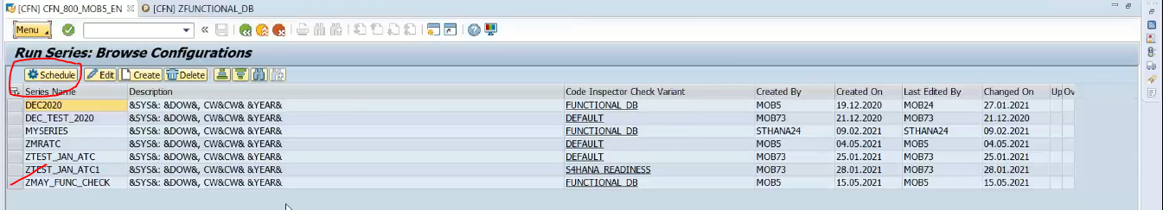

Click on schedule.

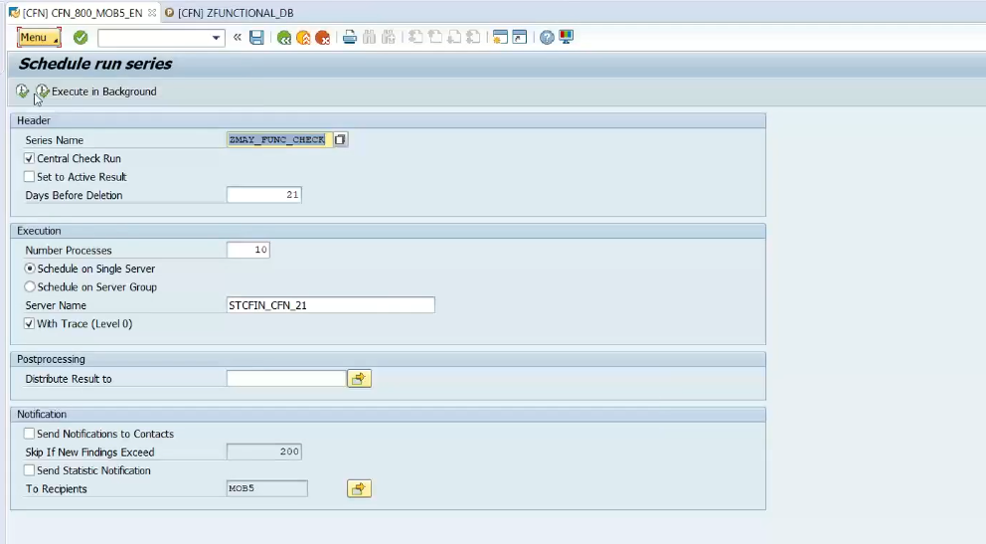

Click on F8- execute.

Message: check run successfully scheduled.

Now where an see the logs now.. directly go to Se80.

OPEN the tcode: SE80 🡨ATC integrated with SE80.

Click on ATC result browser.

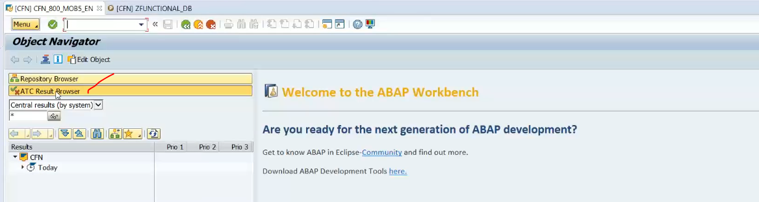

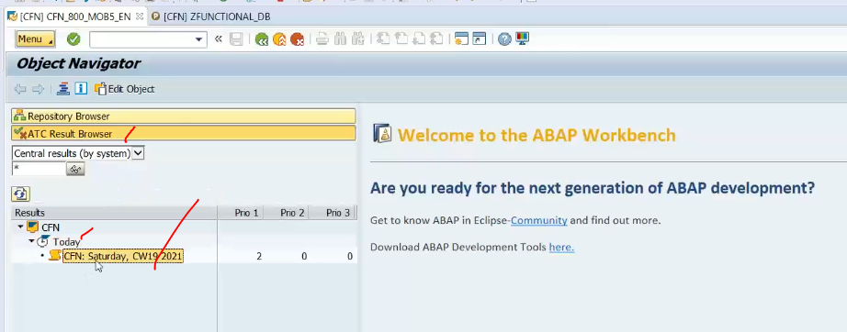

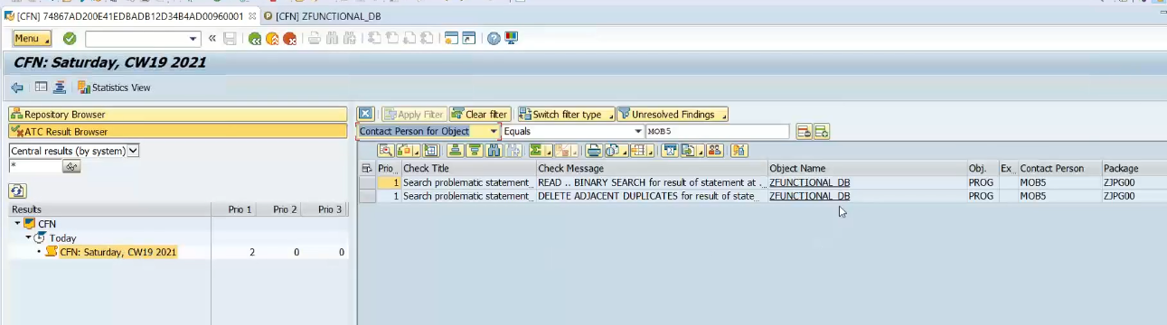

See same finding done in ATC and SCI also.

3rd tool is ADT tool

GOTO hana studio open the program.

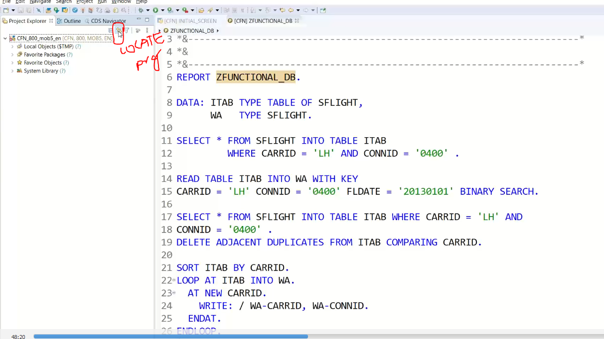

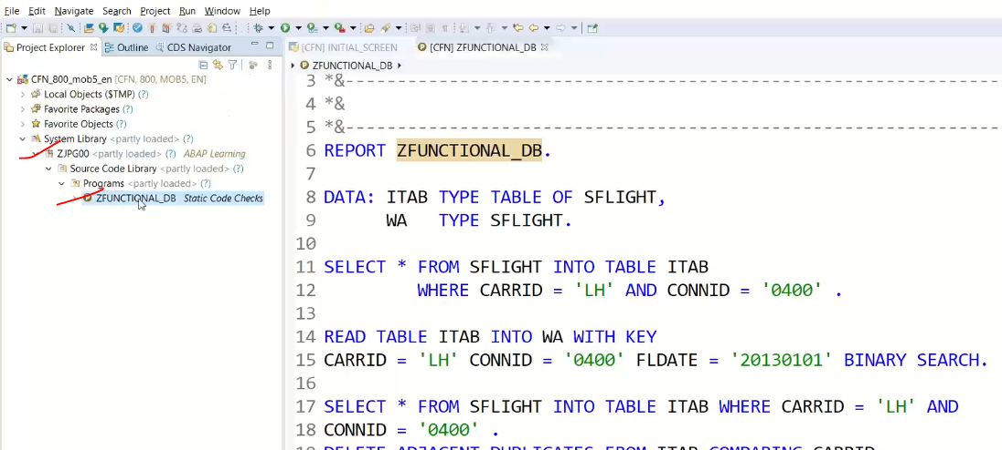

Right click on program name and go to run as 🡪click on abap test cockpit with

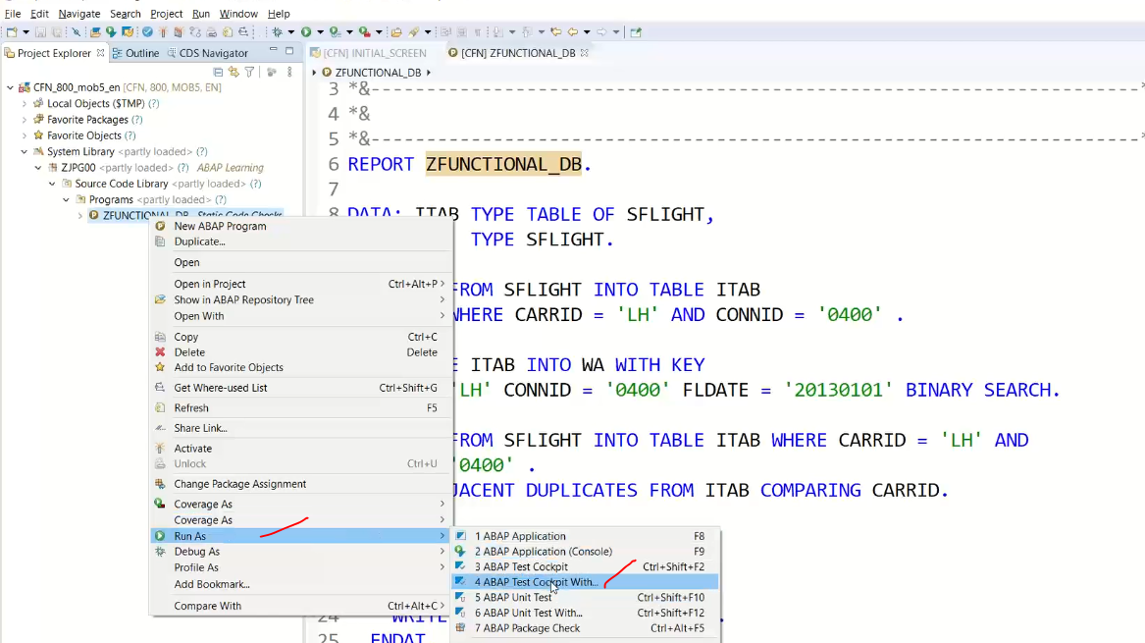

48:00

In next screen provide the variant: FUNCTIONAL_DB

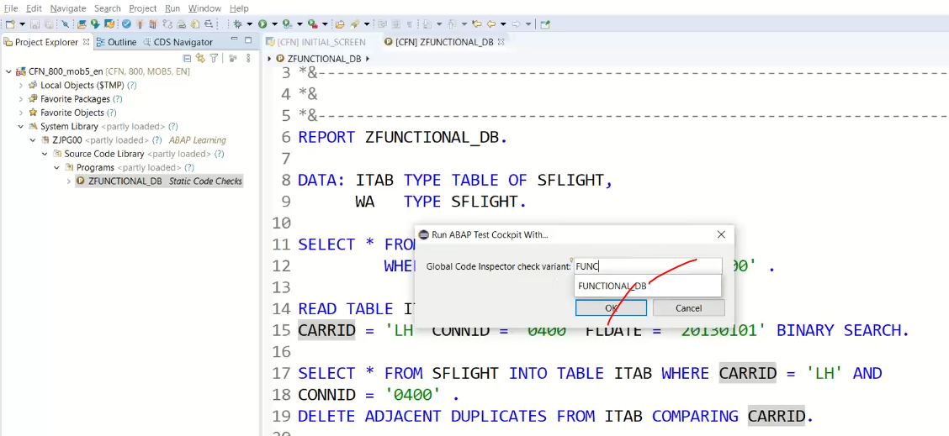

Now it is running in right side

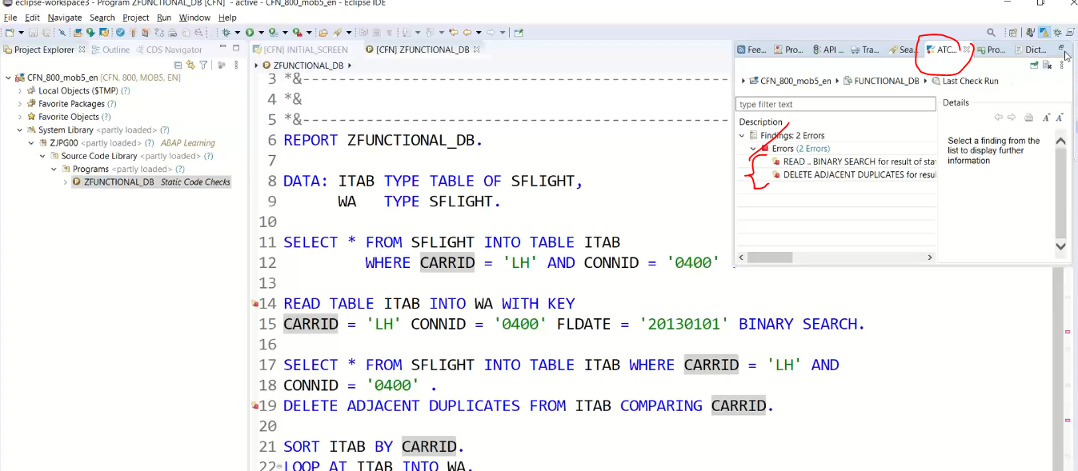

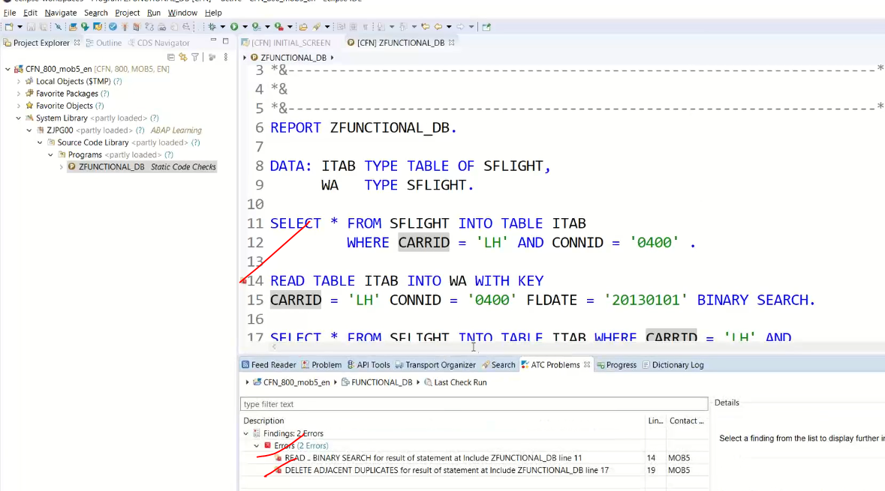

It is also proposing statements to quick fix.

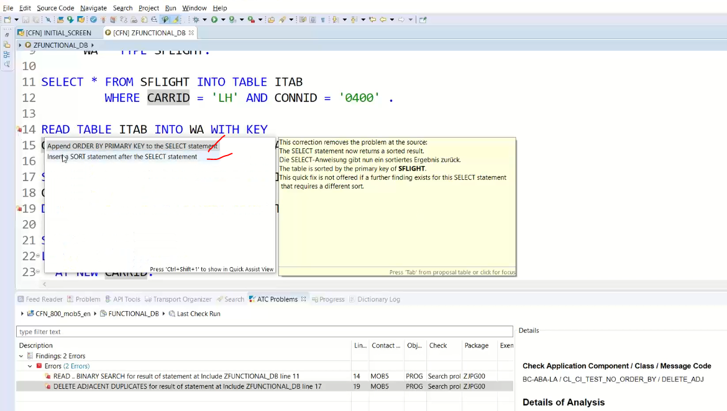

If I select the order by .. it is automatically code insert to the select statement.

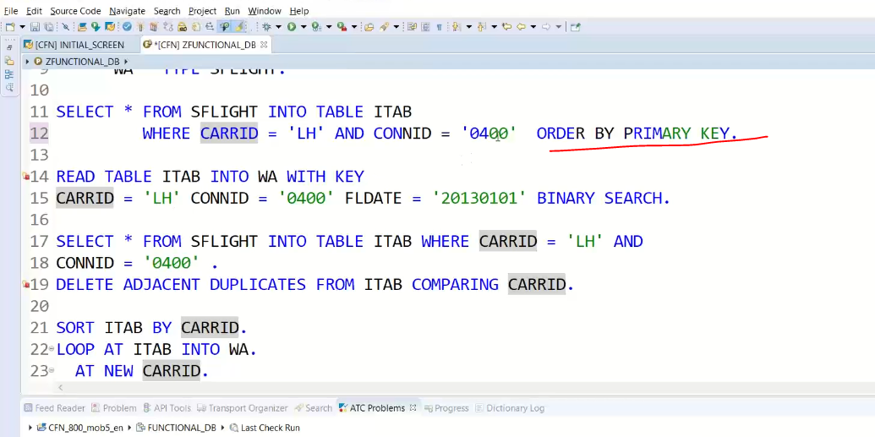

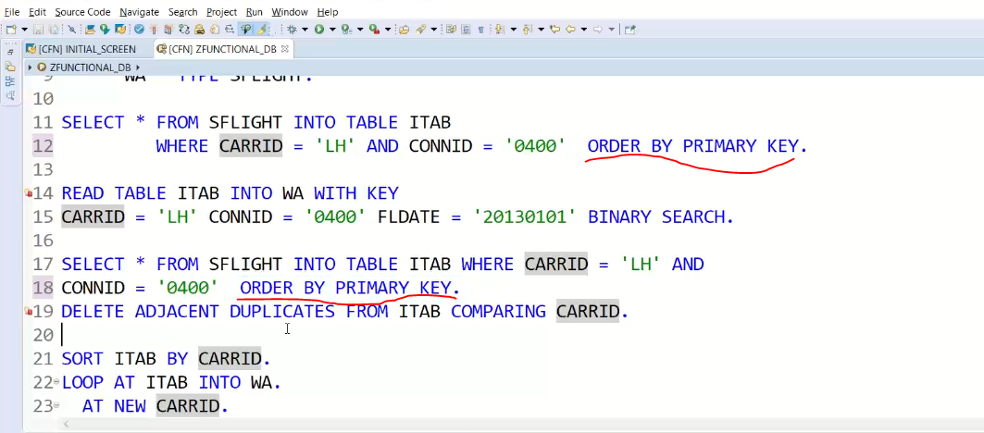

Activate and execute after fix the issues.

Now go back right click , recheck…

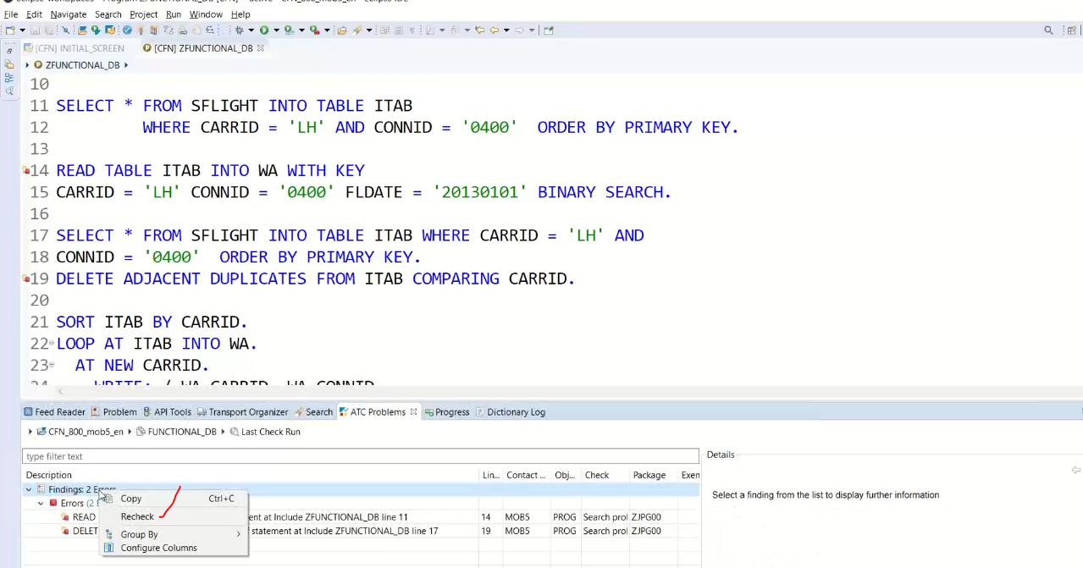

You will not get any error.

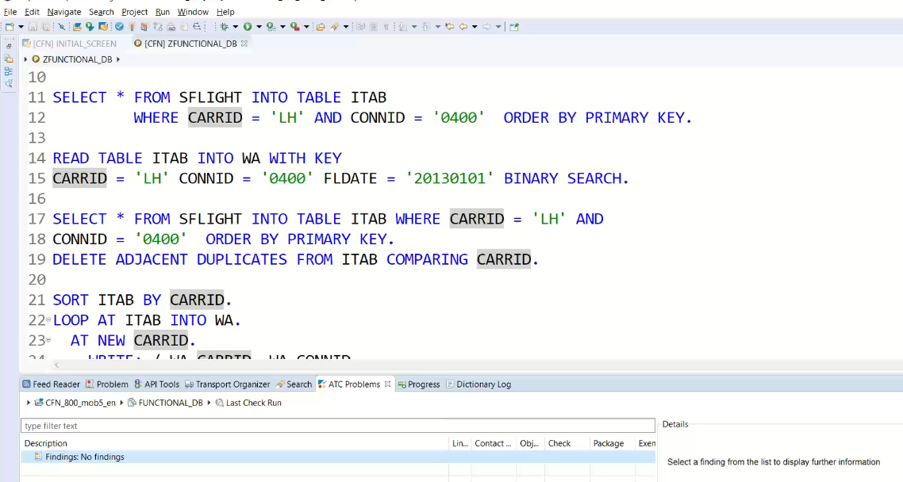

This is also equals to the SCI nd ATC tcodes.

Same result it is giving..

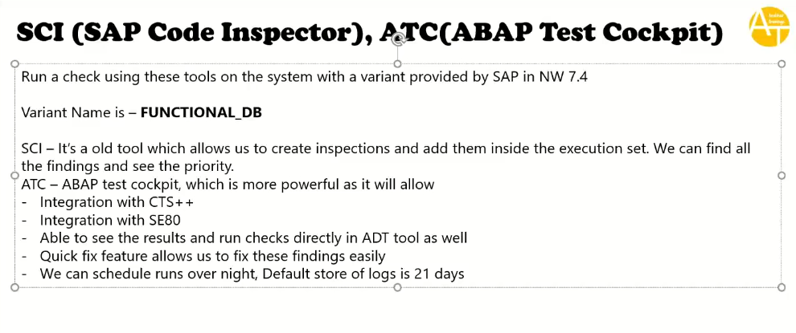

ATC we can integrate with transport request.

1:00:00

SAP has added more checks to the variant: FUNCTIONAL_DB_ADDIITON.

**INTRODUCTION to SAPS4 hana**.

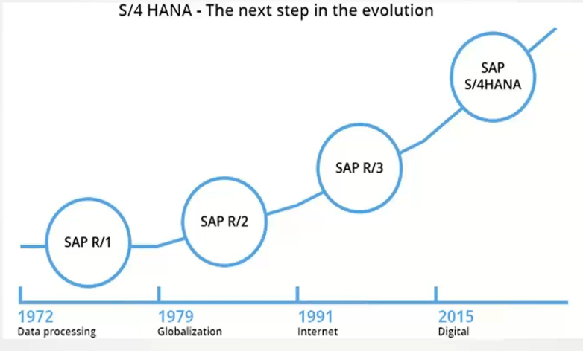

S4 –Simplified 4th generation.

What was simplified in SAP s4 HANA?

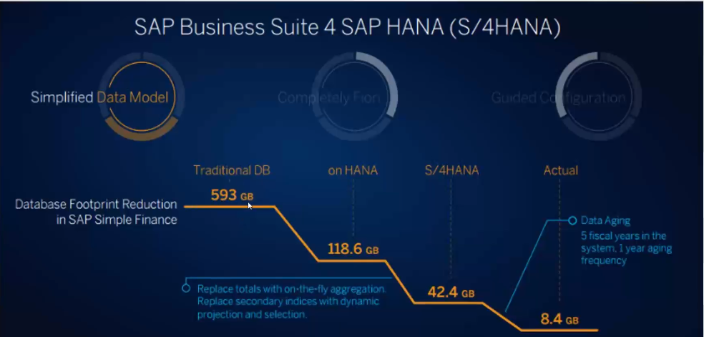

S4 hana is product

ABAP on HANA is technology.

Eventually you are working on s4/hana means you are working on ABAP on HANA.

1. Simplified Data Model: they have actually analyzed all the data base tables of 8000 approximately tables in SAP world. They analyzed those tables and looped at them i.e indexes and tables and they have found if you go to hana do actually don’t need any more secondary indexes in HANA and don’t need any more aggregation tables and no need the cluster/pooled tables , all those were not required anymore.

They have removed all those redundancy in the system, which means they have deleted certain database tables 🡪 this is the big change.

Note: I am using custom table in my program perhaps if it is deleted then it is the big problem and it will start the dumping.

If your company moves to S4HANA and put their Z-Transaction code into S4 HANA many and many of them it starts the dumping because of permanent deletion of tables/data elts /change of data elts.

Ex:

In Above Diagram Traditional DB occupied 593 G, on HANA memory has 118.6 GB because they deleted tables this is called as simplification.

Now in S4 HANA further deleted more tables secondary indices, for secondary indices replace with dynamic projection and selection and entire ERP memory in S4 HANA is 42.4 GB of RAM, now Data Aging 5 yrs of fiscal data it has brought down to 8.4 GB.

Data Aging: HANA is in memory DB and RAM is very expensive and there is spice of data and which may be was not used in last 5 yrs nobody read/change the data, this type of data is eatig memory, nobody did anything on data, How do you know that SAP has introduced called data aging field and this field is time stamp field🡪 every time hit SQL this field change automatically based on this we can data was used/changed.

If nobody touch the data is last 5 yrs why do I waste my RAM to keep this data, why not this data move to hard disk. Based on aging field SAP HANA does this automatically if it is very old data and not done on any actions these data it is moving to Hard disk.

MATDOC table: is the main table for material aggregation data

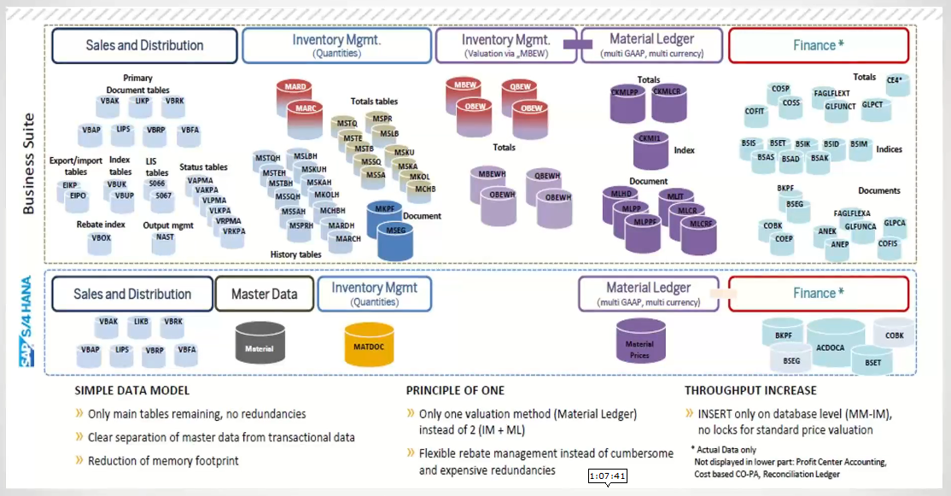

What about my custom code while migrating to old system to S4 HANA?

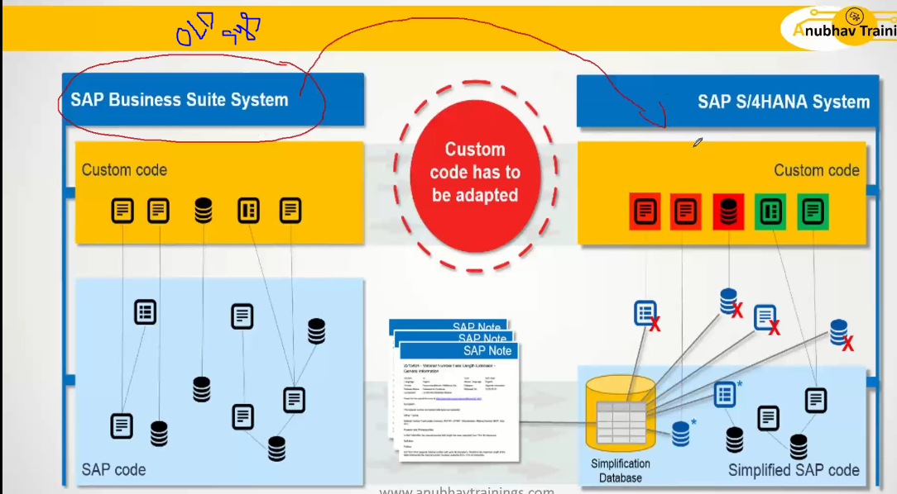

Here we are converting to S4 HANA, old DB tables and old artifacts are available in S4 hana.

In S4 HANA previous code and DDIC objects are documented inside the S4 hana it is called as simplification Data base then only you can’t get the dump while upgrading system.

This simplification data base download with latest zip file from SAP market place and this zip file import to the simplified data base using tcode- SYCM.

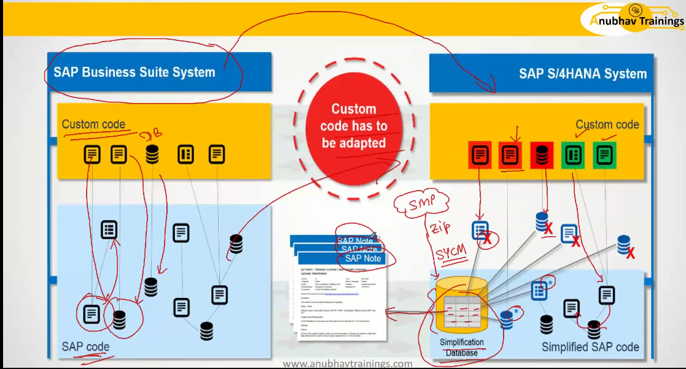

**TCODE- SYCM🡨 simplification data base download from service market place and upload using SYCM tcode, then only you will get all the list of simplification items( what were changed and what were deleted items) each simplification record available in simplification Data base**

Here you have the simplification data base and it has got items each item points to a NOTE(SAP NOTE) and eventually you have a lots of lots simplification items and each one of them perhaps points to one note or multiple notes and their you will find the information what was being their changed .

As a developer first thing you need to update the Data base, this will be done by basis, as a developer you should understand all those things now we will learn how to download the simplification DB from service market place and how to upload this into the simplification DB.

1. Login to the Service Market Place for login we need suserid.
2. Go to software downloads and check below snap.

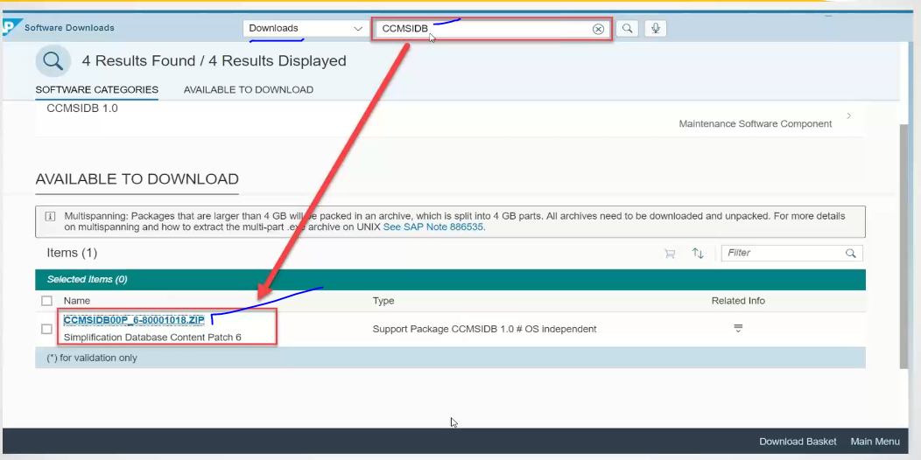

This is the simplification database zip file

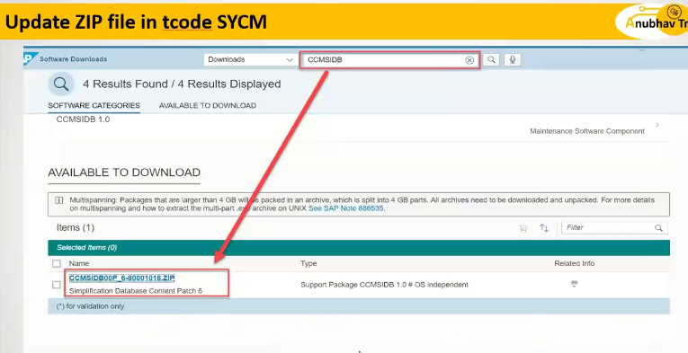

1. Download this zip file into your computer and upload this through the SYCM.

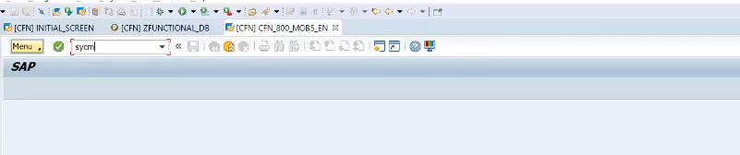

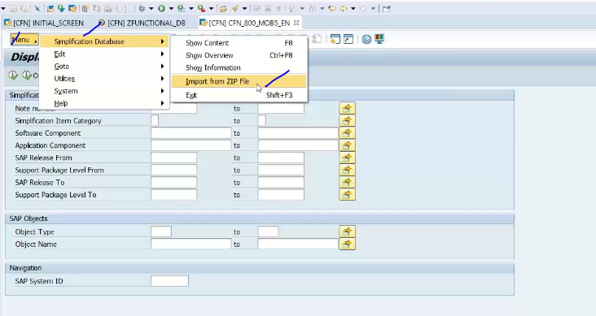

Now you can able to upload that file.

Once upload, I want to see the any change in MARA object

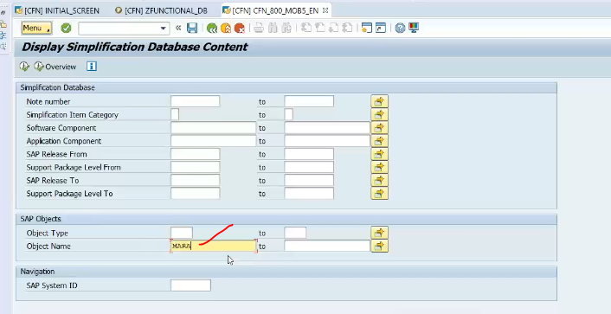

Execute:

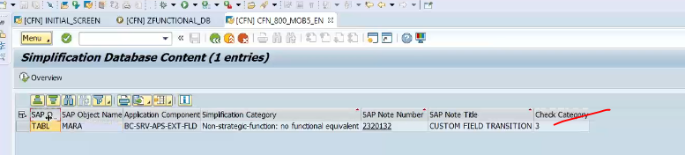

If any record exist, so there is changes in MARA object. 🡪NON-Strategic function: no functional equvalent and you will get SAP Note:2320132, if you click this SAP note will open in launch pad.

And now login with “suserid” and then login properly.

Login screen with data:

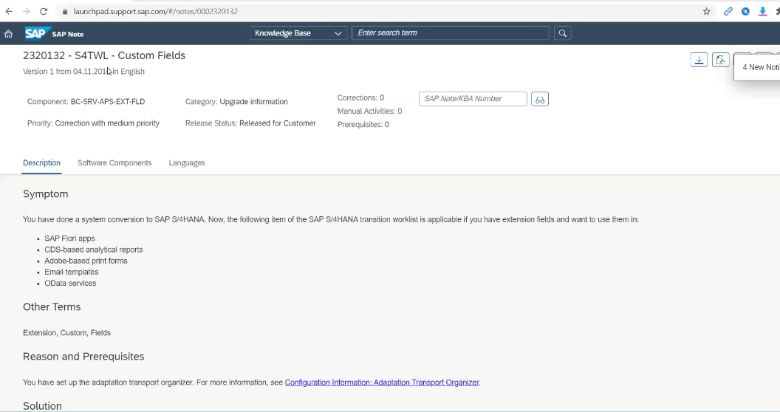

Note: every particular object you will have the lot of changes and lot of adoptions needs to be done .

As a developer how do we adopt the custom code.

Ex: incompatible material types

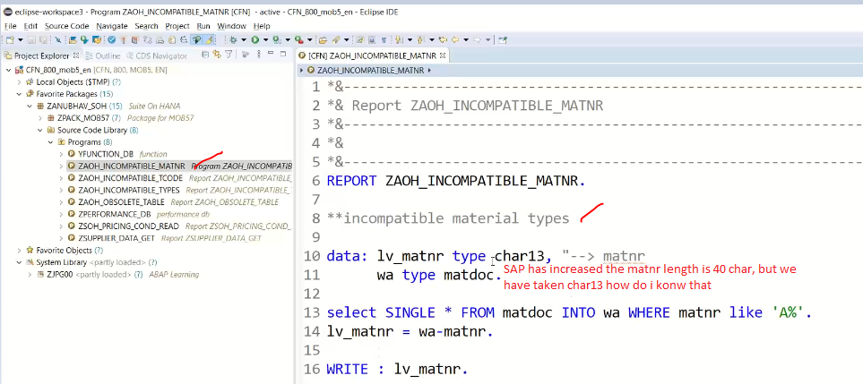

Ex: incompatible tcode

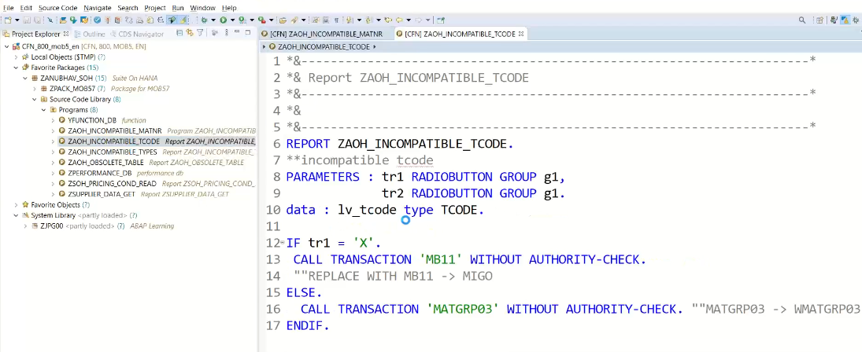

F8

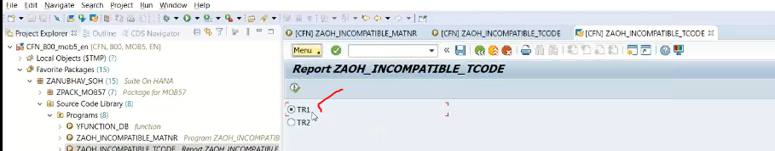

F8

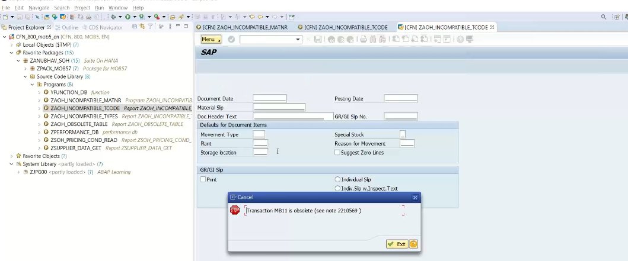

And execute with tr2 radio button it is giving dump.

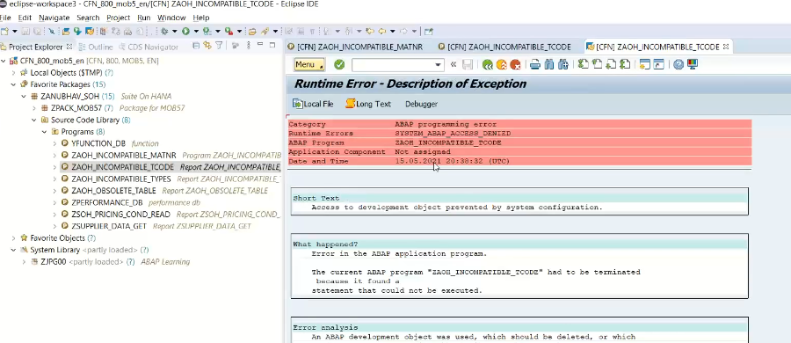

ATC: variant is S4HANA_READINESS 🡪 get the error🡪 this has deleted the permanently

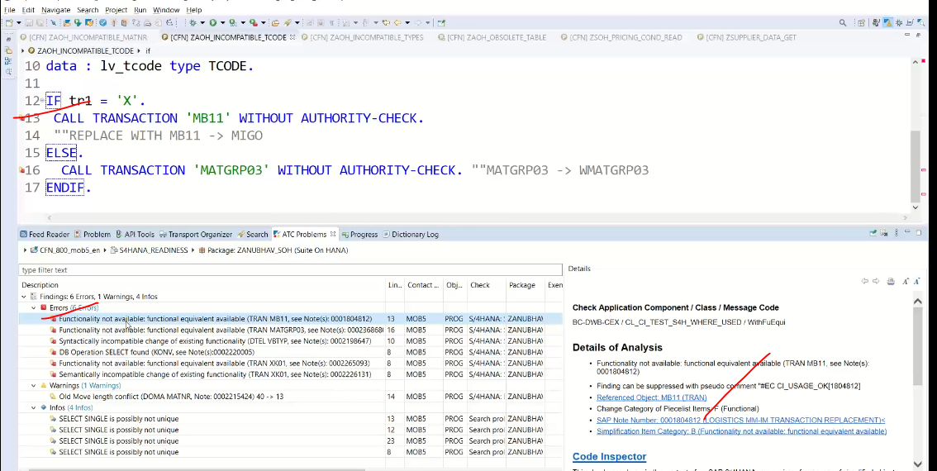

SAP Note number: 0001804812

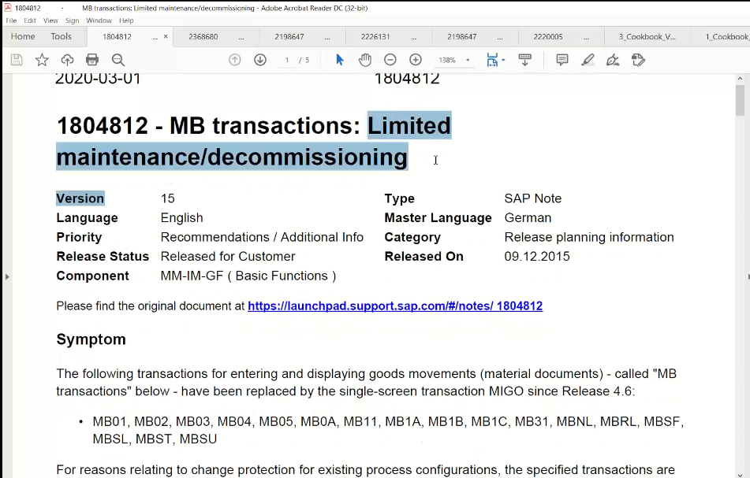

SAP has deleted MB transactions permanently

MB tcodes are replaced with MIGO, MIGO is only tcode for MB tcodes.

Now what to do in our code if deleted the tcodes🡪 just change the TCODE with MIGO.

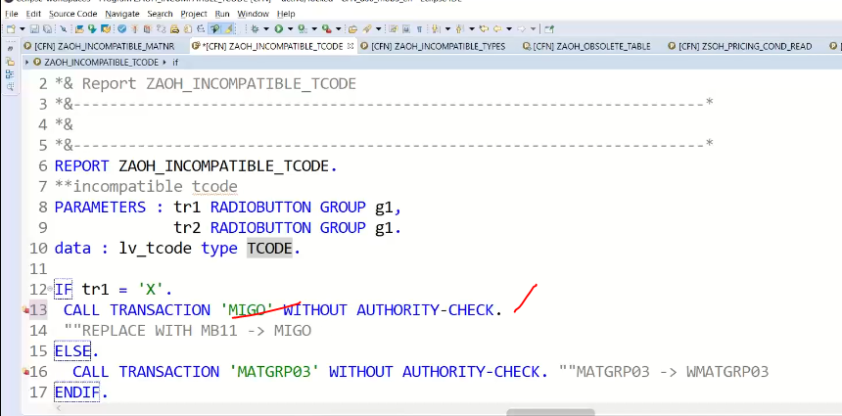

Save and execute 🡪 it will work fine.

In same code 2nd error is “MATGRP03”

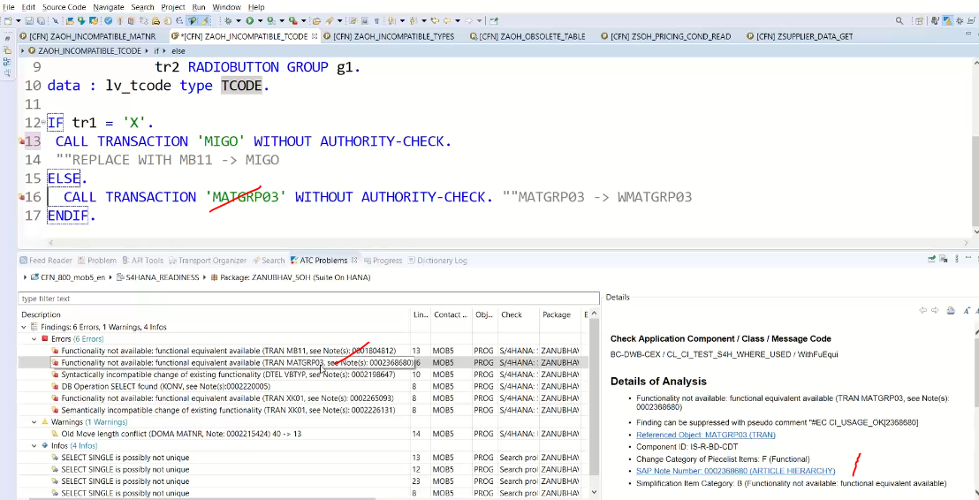

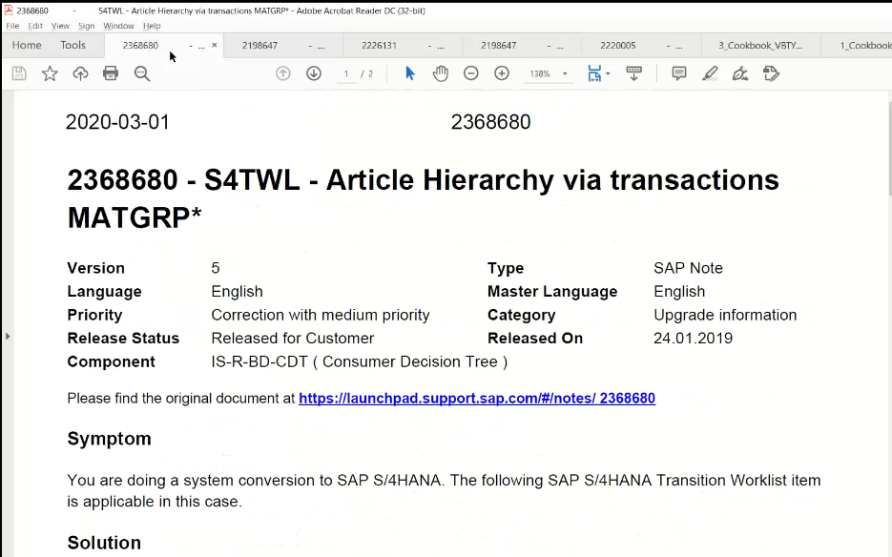 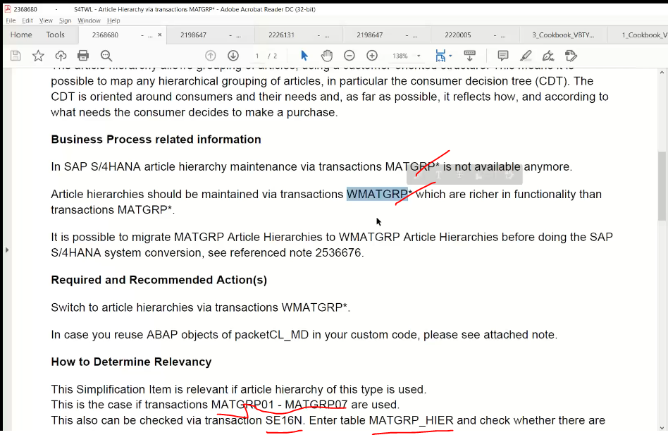

Replace with “MATGRP03” with “WMATGRP03”

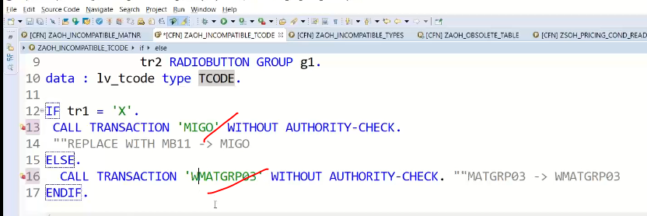

Save and activate

F8

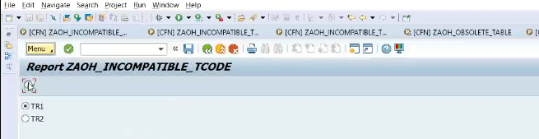

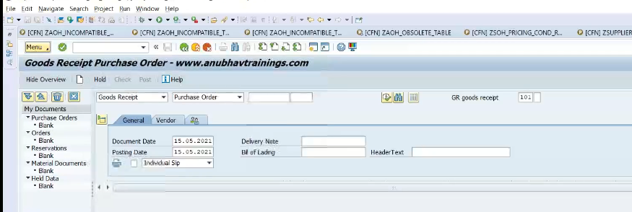

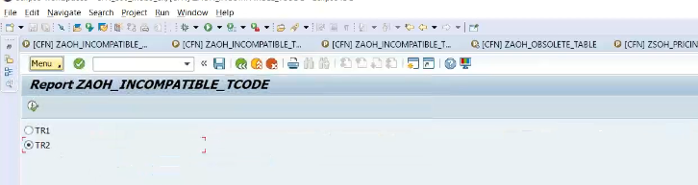

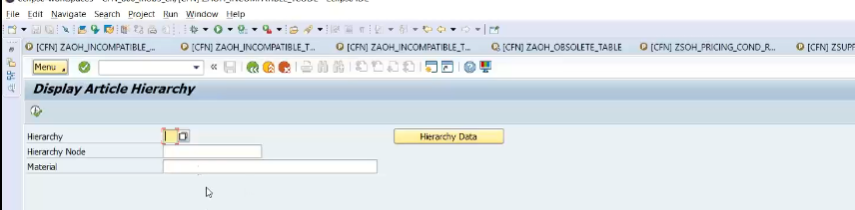

Ex: incompatible type

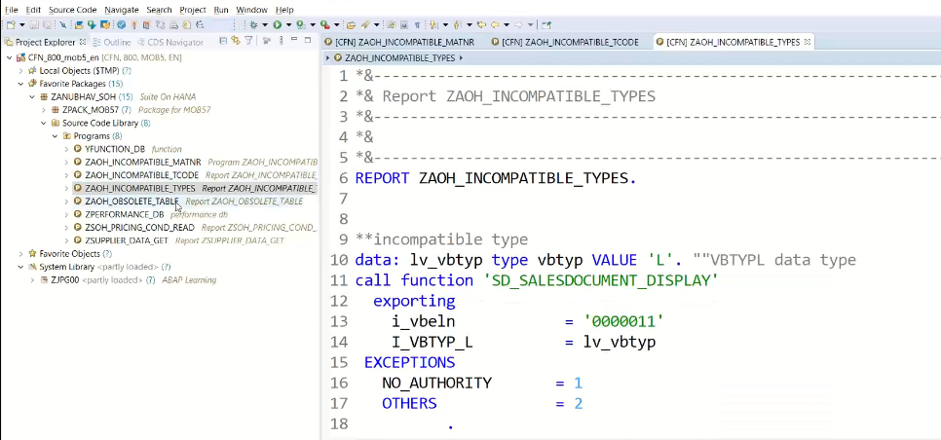

F8:

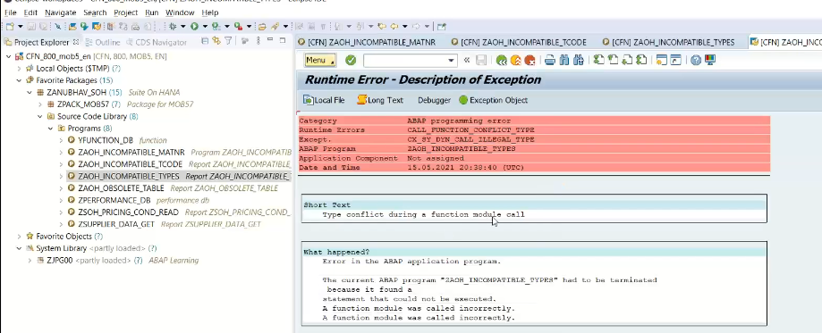

Fix:

Execute ATC cockpit

VARIANT is S4HANA_READINESS

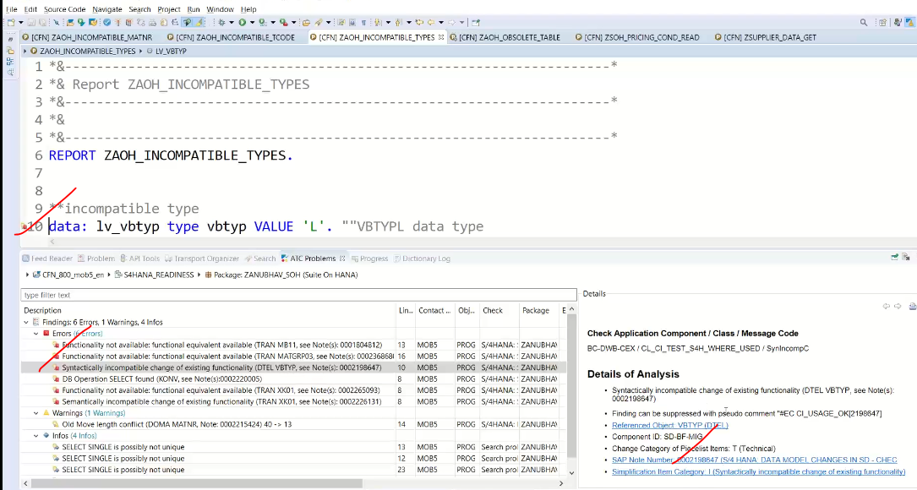

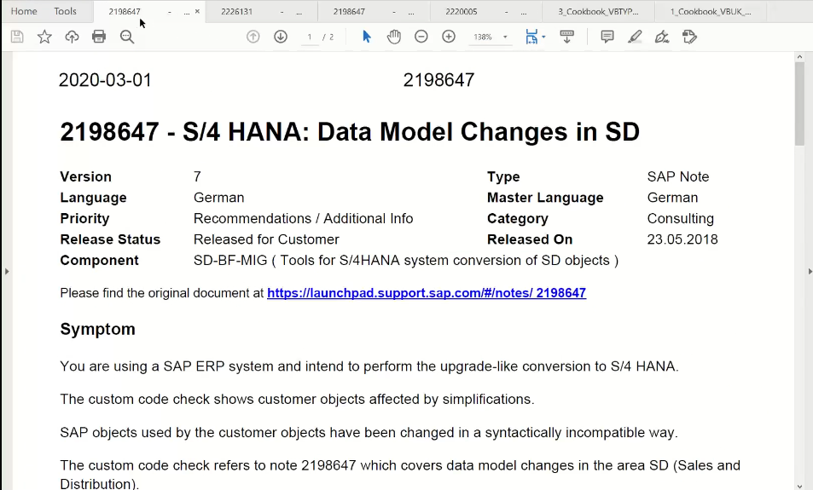 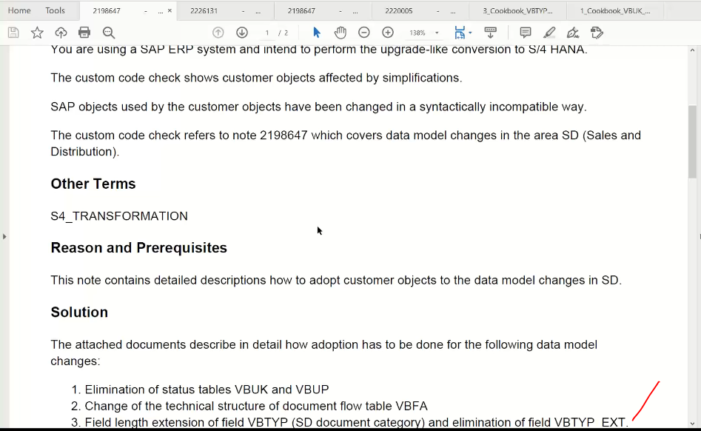 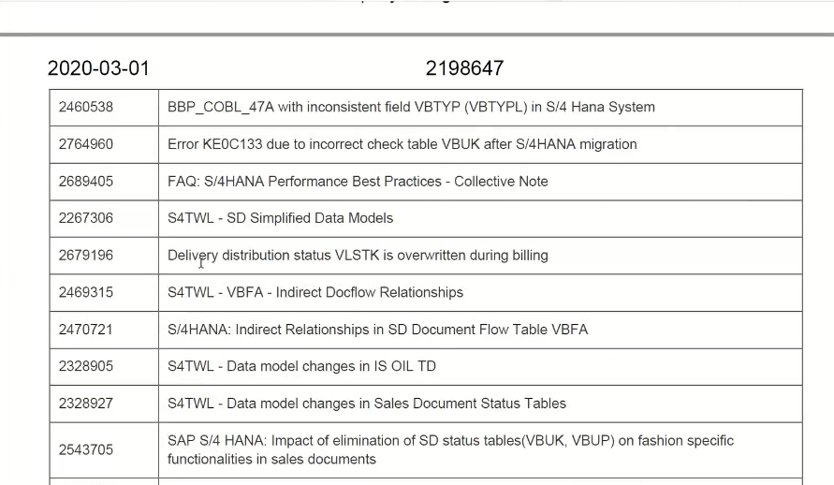

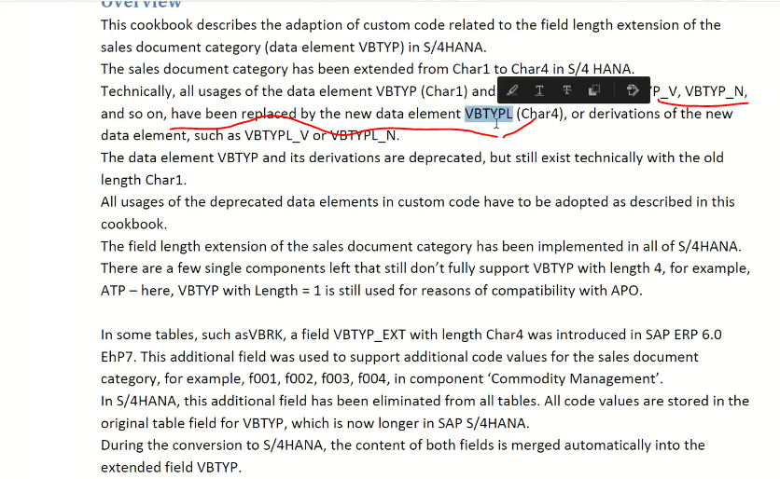

Change the data type : VBTYPL

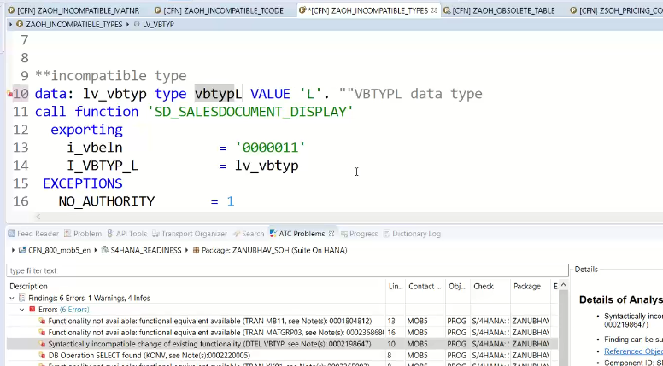

Save and activate

F8:

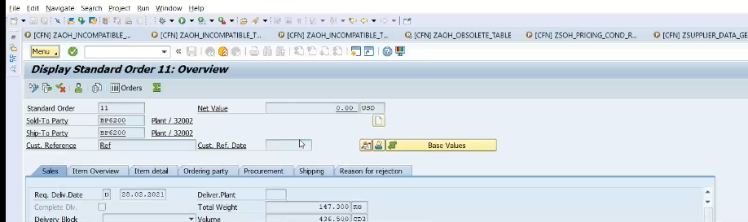

Ex: tables are obselete

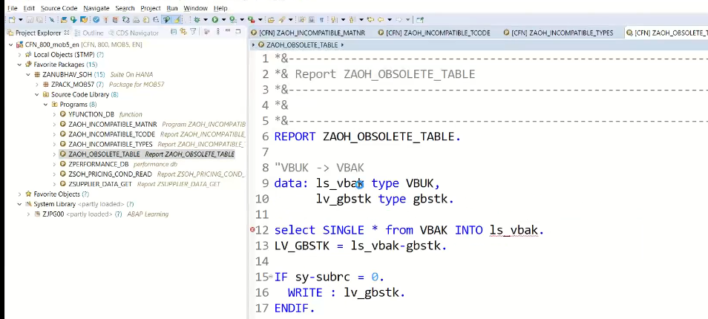

You will get the activation issue.

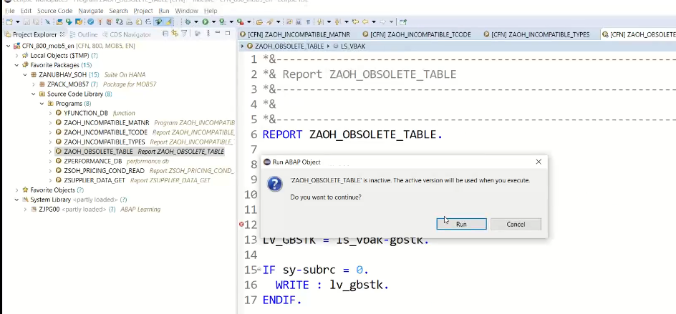

Fix:

VBUK and VBUP has eliminated and same status available in VBAK table.

Replace VBAK in place of VBUK

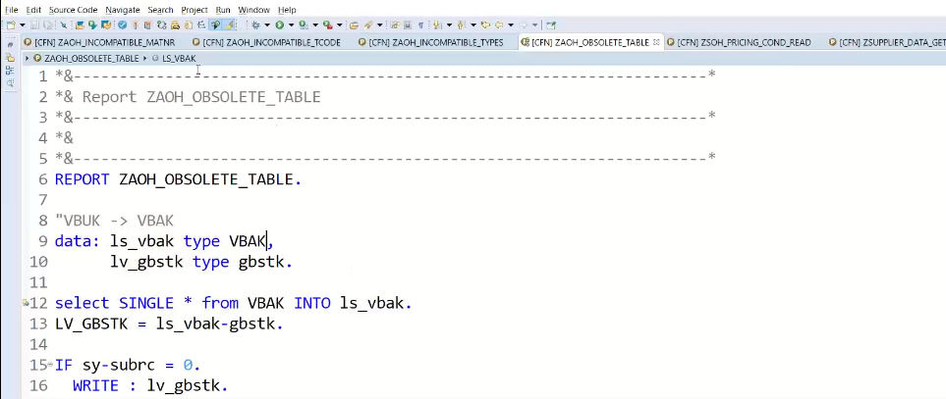

SAVE AND Activate F8

You will not get any syntax errors

Ex: producing blank results

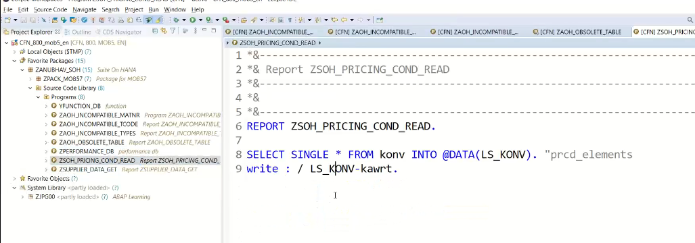

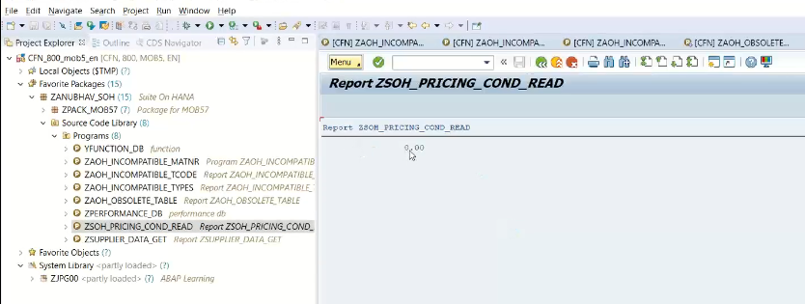

Fix: KONV has no more pricing conditions

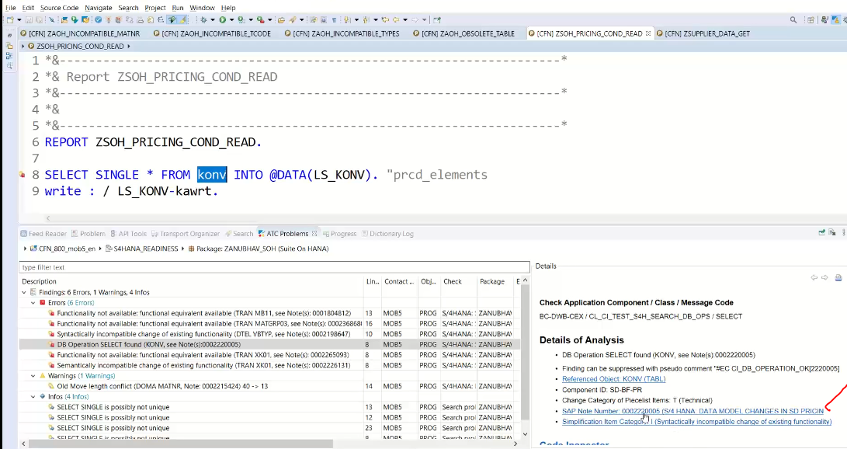

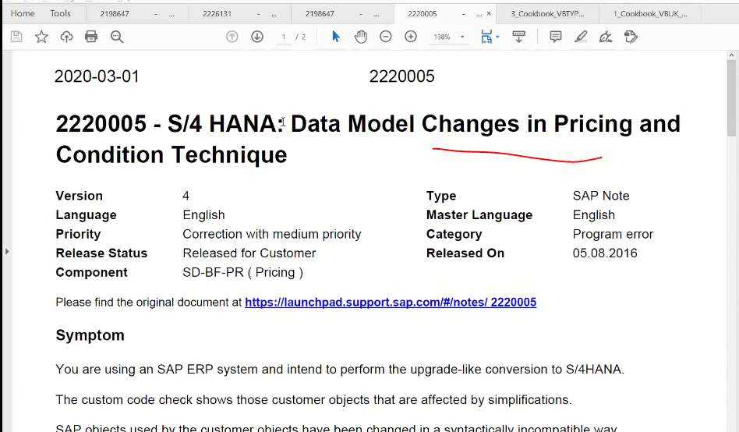

**New table is :PRCD_ELEMENTS for pricing conditions available in place of KONV table**

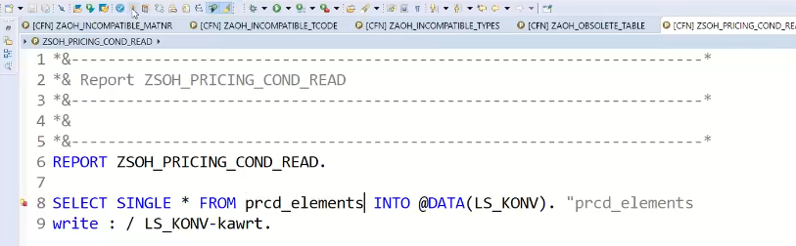

Ex: redirecting to the different tcode.

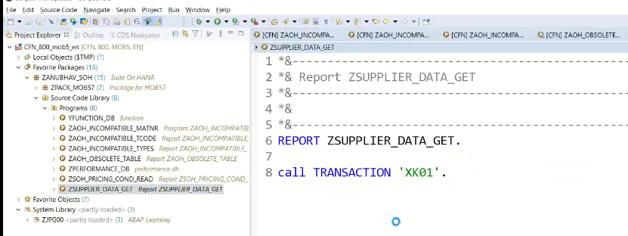

F8

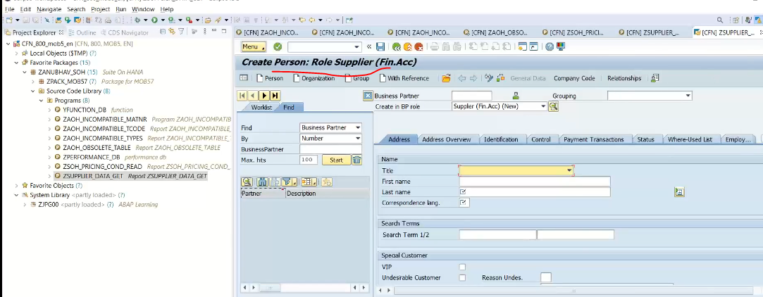

Fix:

XK01 tcodes are permanently deleted

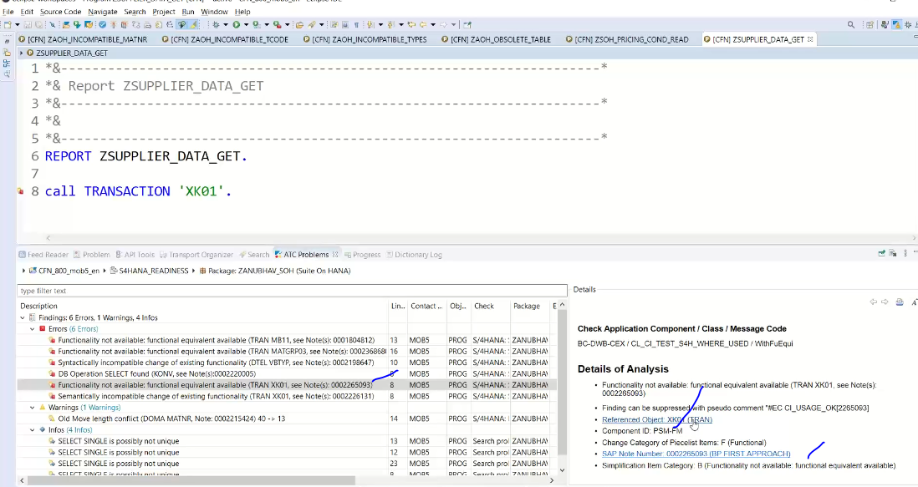

To update the vendors central **tcode is BP available in palce of XK01**

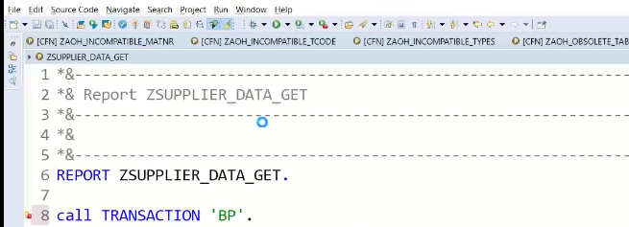

This type of error will come while migration old system(ECC) to S4 hana.

This type of errors will detect from SCI/ACT tools using FUNCTIONAL_DB variant while migrating ECC to HANA (ECC suite) only but ECC/Business suite to S4 hana will not work, in this case we can use it as S4 HANA readiness check. variant

ECC to S4 HANA🡪 variant is S4HANA_READINESS

How to do that?

1. Go to entire pkge🡪 right click

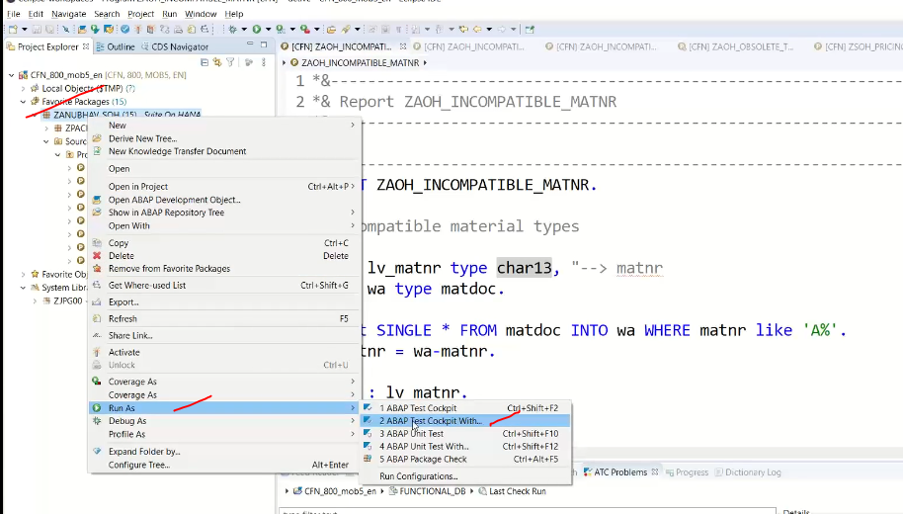

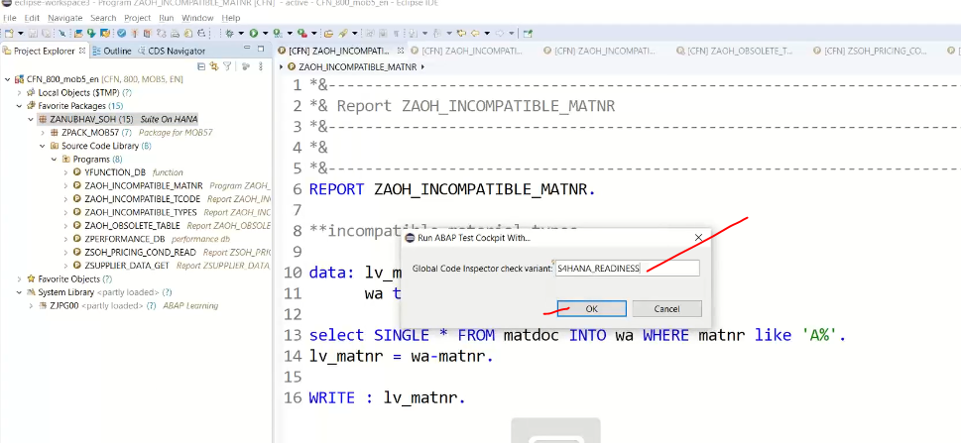

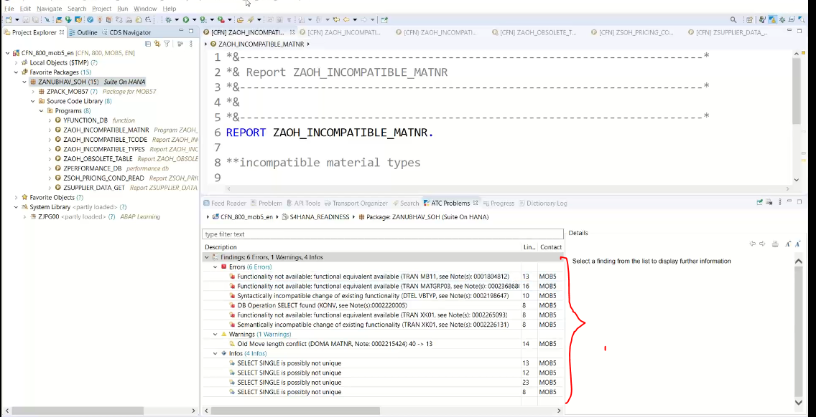

These all are incompatible mode.

Once everything has fixed and recheck one more time 🡪 you will not get any error.

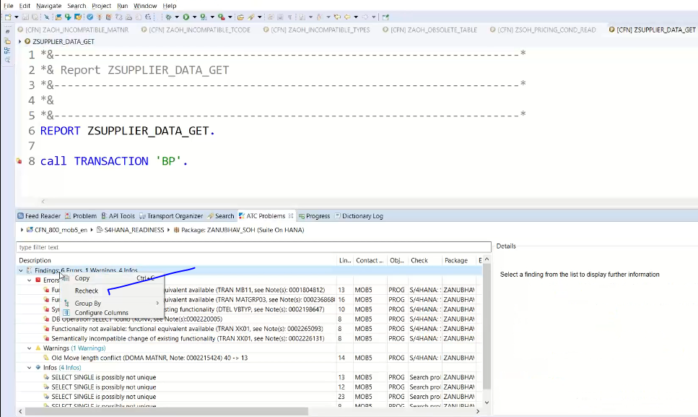

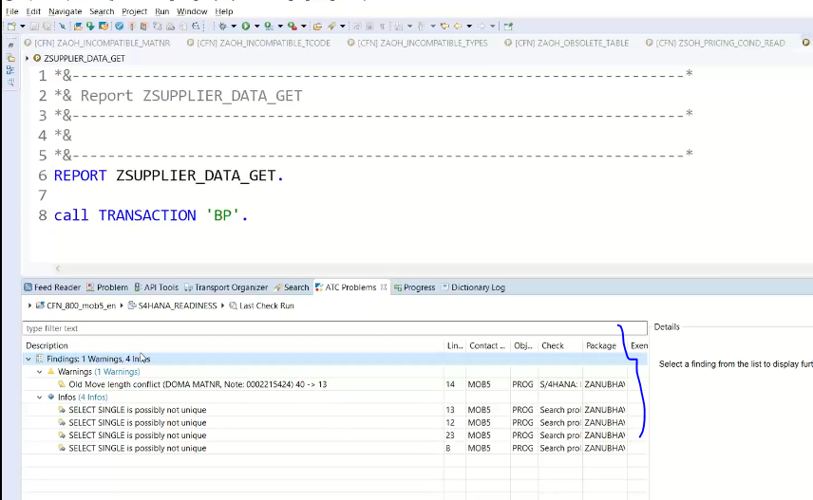

No errors

S4HANA_READINESS work in A(ECC)🡪C(S4 HANA) or B(Business Suite)🡪C(S4HANA)

FUNCTIONAL_DB variant is used in A🡪B(HANA)

<https://blogs.sap.com/2016/02/02/sap-s4hana-custom-code-migration-worklist/>

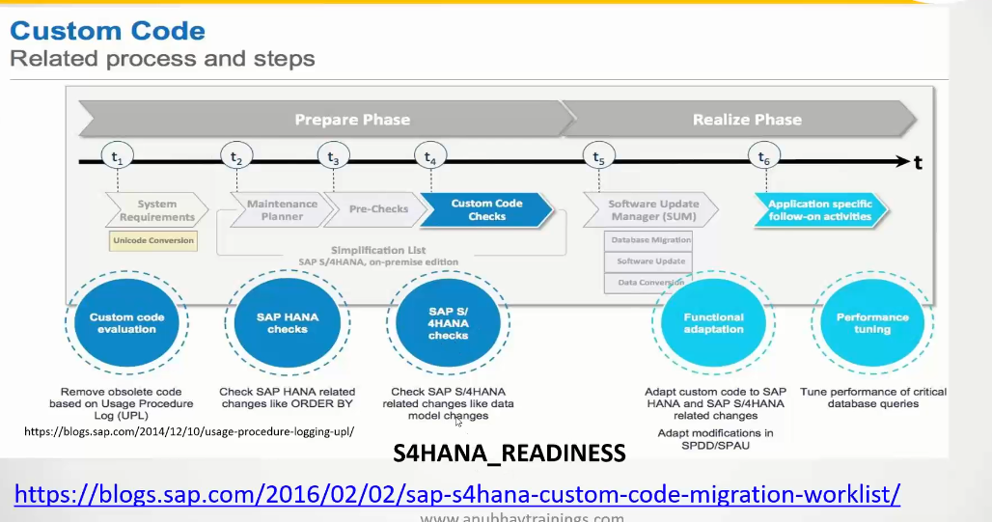

Upload zip-file into analysis system using report SYCM_UPLOAD_SIMPLIFIC_INFO/SYCM

GUI: S4HANA_READINESS

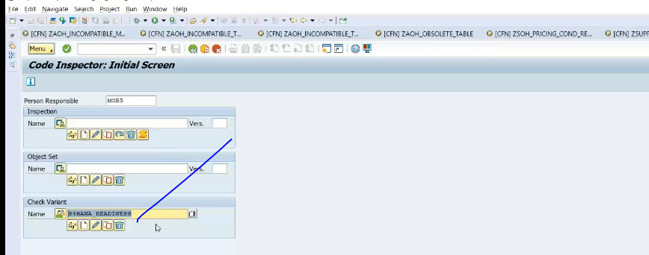

Opening to NEW sessions: CTRL + 6